aseXML Schema Change Request
PREPARED BY: Wayne Lee
DOCUMENT REF: CR60
VERSION: 0.4
DATE: 10-Mar -2017
Draft/Final DRAFT
Version Release History
Version | Date | By | Changes
0.1 | 27/01/2017 | Wayne Lee | Change proposal for POC B2B.
0.2 | 24/02/2017 | Wayne Lee | Updated after January POC B2B consultation feedback and IEC response to the versions updated with feedback.
0.3 | 24/02/2017 | Wayne Lee | Updated after ASWG walkthrough of 0.2.
0.4 | 10/03/2017 | Wayne Lee | Updated after ASWG feedback of 0.3  Removed TransformerLocation from InstrumentTransformer.  InstrumentTransformerType max reduced to 2 from 20.  Modified enumerated values for SORDResponseCode  Modify PrimaryVoltage to be 8 char max.

Glossary
Abbreviation | Description

Contents
1 Change Proposal 5
1.1 Description of the proposed change 5
1.2 Reason for Change 7
1.3 Supplied Documents 7
1.3.1 Other 7
1.4 Baseline Schema 7
2 Approval Proposal 8
2.1 Proposed Change 8
2.1.1 Draft schema 8
2.1.2 Change log 8
2.1.3 Schema change description 12
2.1.4 Impact Summary 46
2.1.5 Developer Test 48
3 Proposal Assessment 48
3.1 Test 48
3.1.1 Test Platforms 48
3.1.2 Test Cases 48
3.1.3 Test Results 48
3.2 Conformance Report 48
4 Issue Register 48
4.1 Status of Issues 49
5 Resolution 49
5.1 ASWG Endorsement 49

Change Proposal
This Change Proposal is to provide changes required to support the Power of Choice program:
- Enable multiple notified parties to be specified in the service order request and response transactions.
- Provide a one way notification type transaction to deliver details and progress information on service orders to multiple notified parties as a one way notification.
- Implement site access request transactions as customer and site detail transactions.
- Provide remote service request and response transactions as metering transactions.
- Provide notice of metering works transaction as a one way notification.
- Add life support, meter safety certificate, and coordination information to service order request transactions.
- Add email address to customer details notification.
- Modify the SwitchingServiceRequired element from Boolean to string.
- Update enumerations used in service order type and service order sub-type to reflect new Power of Choice requirements.
- Add PTPDataExchange freeform transaction to support unbounded peer to peer exchanges.
- Add PlannedInterruptionNotification transaction.
- Add MeterFaultAndIssueNotification transaction.
- Add new transaction groups to assign against the new transaction types.

Description of the proposed change
The proposed changes are listed in the following table.
Item# | Change Description | Change Type
 | Modified Simple Type  Added enumeration values to IndexInvestigationCode  Added and removed enumeration values to ServiceOrderType  Added and removed enumeration values to ServiceOrderSubType  Added and removed enumeration values to SORDResponseCode  Added enumeration values to TransactionGroup  Added enumeration values to SupplyPhase  Changed SwitchingServiceRequired from Boolean to string.  Changed MeteringType to remove enumerated list.  Modified Complex Type  Transaction  ElectricityMeter  Product  ElectricityMeterRegisterDetail  ElectricityStandingData  ElectricityMasterStandingData  ElectricityServiceOrderDetails  GasServiceOrderDetails  ServiceOrderRequest  ServiceOrderResponse  CustomerDetailsNotification  ElectricityServiceOrderNotificationData  ElectricityServiceOrderType | Enhancement
 | New Simple Type  SiteRequestReason  EnergisationStatus  GenerationType  PrimaryVoltage  InstrumentTransformerType  DeviceSerialNumber  DeviceLocation  ControlEquipmentSerialNumber  ControlEquipmentType  ControlChannel  InstrumentTransformerSerialNumber  De-energisationReason  RegisterIndexValue  ResponsePayload  RemoteServiceRequestCode  UserDefinition  RemoteServiceType  ResponseFormat  ServiceRequestID  Latitude  Longitude  NoticeOfWorksID  WorkType  NotificationStatus  NotificationNotes  r36  EmailAddress  AttachmentName  AttachmentType  ReasonForInter  ReasonForNotice  SupplyOff  Duration  New Complex Type  SiteAccessRequest  NetworkDevices  NetworkDevice  ControlEquipments  ControlEquipment  InstrumentTransformer  InstrumentTransformers  ConnectedMeters  RemoteServiceData  RemoteServiceResponseData  UserDefData  RemoteServiceResponse  RemoteServiceRequest  MeterSerialNumbers  GeographicCoordinate  NotifiedParties  WorksDetail  NotificationPayload  RemovedMeteringEquipments  RemovedMeteringEquipment  NewEquipment  NoticeOfMeteringWorks  NotifiedParty  PTPDataExchange  P2PAttachment  AttachmentList  PlannedInterruptionNotification  MeterFaultAndIssueNotification | New
New include file
P2P_r36.xsd

Table 1-1, Proposed Changes

Reason for Change
Provide changes required to support the Power of Choice program.

Supplied Documents

Other
aseXML_r36.zip

Baseline Schema
The schema used as a basis for this proposal is aseXML_r35.

Approval Proposal

Proposed Change

Draft schema
Draft schema created as aseXML_r36.

Change log
The following changes have been implemented in this draft:
Chg # | Item # | Description of change | Filename
1 | 1 | Updated schema namespace to ‘urn:aseXML:r36’.  Updated Transactions schema to Transactions_r36.xsd  Updated CustomerDetails schema to CustomerDetails_r36.xsd  Updated Electricity schema to Electricity_r36.xsd  Updated ElectricityMasterStandingData schema to ElectricityMasterStandingData_r36.xsd  Updated MeterDataManagement schema to MeterDataManagement_r36.xsd  Updated Common schema to Common_r36.xsd  Updated OneWayNotification schema to OneWayNotification_r36.xsd  Updated ServiceOrder schema to ServiceOrder_r36.xsd  Updated Events schema to Events_r36.xsd  Updated Gas schema to Gas_r36.xsd.  Added Peer to Peer schema as P2P_r36.xsd  File version changed from r35 to r36. | aseXML_r36
2 | 1 | Added r36 release identifier in the Event schema.  File version changed from r35 to r36. | Events_r36
 |  | Added the following complex types for new transactions.  - SiteAccessRequest  - RemoteServiceResponse  - RemoteServiceRequest  - NoticeOfMeteringWorks  - NotifiedParty  - PlannedInterruptionNotification  - MeterFaultAndIssueNotification  - PTPDataExchange  File version changed from r34 to r36. | Transactions_r36
 |  | Added the following Simple Types  - SiteRequestReason (max 40 string)  Added the following Complex Types for new transactions.  - SiteAccessRequest  Modified the following Complex Types  - CustomerDetail  - Added EmailAddress as EmailAddress type.  - CustomerDetailsNotification (set to r36 version)  - Product  - Remove limit on Code element repeats.  File version changed from r34 to r36. | CustomerDetails_r36.xsd
 |  | Added the following Simple Types  - EnergisationStatus  - GenerationType. Max 5 string.  - PrimaryVoltage Max 8 string.  - DeviceLocation  - DeviceSerialNumber  - ControlEquipmentSerialNumber  - ControlEquipmentType  - ControlChannel  - InstrumentTransformerType. Max 2 string.  - InstrumentTransformerSerialNumber  - De-energisationReason  - SwitchingServiceRequired type  - RegisterIndexValue type  Added the following Complex Types  - NetworkDevices  - NetworkDevice  - ControlEquipments  - ControlEquipment  - InstrumentTransformer  - InstrumentTransformers  - ConnectedMeters type  Modified the following Simple types  - ServiceOrderType  - Add enumerated values  - Remove redundant enumerated values  - ServiceOrderSubType  - Add enumerated values  - Remove redundant enumerated values  - SORDResponseCode  - Add enumerated values  - Remove redundant enumerated values  - SupplyPhase  - Add enumerated values  - MeteringType  - Remove enumerated list and set maximum length to 240 characters.  Modified the following Complex types  - ElectricityMeter  - Add SupplyPhase  - Add GenerationType  - Add InstrumentTransformers  - Add GeneralSupply as YesNo type  - Add ControlEquipments for where associated with the meter.  - ElectricityServiceOrderDetails type (set to r36 version)  - Add MeterLicense  - Add De-energisationReason  - Add LifeSupport  - Add Co-ordinationRequired  - Modify SwitchingServiceRequired to be of type SwitchingServiceRequired as varchar(80) from boolean.  - ElectricityMeterRegisterDetail  - Add RegisterIndexValue as type RegisterIndexValue  - Change the version attribute of versioned type to r36:  - ElectricityStandingData  - ServiceOrderRequestData  - ElectricityServiceOrderNotificationData  - ElectricityServiceOrderType  File version changed from r35 to r36. | Electricity_r36.xsd
 |  | Modified the following Complex types  - ElectricityMasterStandingData  - Add EnergisationStatus  - Add PrimaryVoltage  - Add ControlEquipments  - Add NetworkDevices | ElectricityMasterStandingData_r36.xsd
 |  | Added the following Simple Types  - RemoteServiceRequestCode.  - RemoteServiceType.  - UserDefinition  - ResponseFormat.  - ServiceRequestID.  Added the following Complex Types  - ResponsePayload.  - RemoteServiceData.  - RemoteServiceResponseData.  - UserDefData.  - MeterSerialNumbers.  Added the following Complex Types for new transactions  - RemoteServiceResponse  - RemoteServiceRequest  File version changed from r33 to r36. | MeterDataManagement_r36.xsd
 |  | Added the following Simple Types  - Latitude.  - Longitude  Added the following Complex Types  - NotifiedParties.  - GeographicCoordinate  Modified the following simple types  - Added enumeration values to IndexInvestigationCode  - Verify/Missing Register  - Require Estimate Data  - Meter Churn  File version changed from r34 to r36. | Common_r36.xsd
 |  | Added the following Simple Types  - NoticeOfWorksID as string.  - WorkType as string.  - NotificationStatus as string  - NotificationStatus as string  - ReasonForInter as string  - ReasonForNotice as string  - SupplyOff as string  Added the following Complex Types  - WorksDetail  - NotificationPayload.  - RemovedMeteringEquipments  - RemovedMeteringEquipment  - NewEquipment  Added the following Complex Types for new transactions  - NoticeOfMeteringWorks transaction.  - NotifiedParty transaction.  - PlannedInterruptionNotification  - MeterFaultAndIssueNotification  File version changed from r33 to r36. | OneWayNotification_r36.xsd
 |  | Modified the following Complex types  - ServiceOrderRequest (set to r36 version)  - Add NotifiedParties  - Add Co-ordinatingContactDetail  - ServiceOrderResponse (set to r36 version)  Change the version attribute of versioned type to r36:  - ServiceOrderRequest  - ServiceOrderResponse  File version changed from r33 to r36. | ServiceOrder_r36.xsd
 |  | Added the following Simple Types  - EmailAddress as string type.  File version changed from r15 to r36. | ClientInformation_r36.xsd
 |  | Modified the following Simple types  - TransactionGroup  - Add enumerated values | Header_r36.xsd
 |  | Added the following Simple types  - AttachmentName  - AttachmentType  Added the following Complex types  - P2PAttachment  - AttachmentList  Added the following Complex Types for new transactions  - PTPDataExchange | P2P_r36.xsd
 |  | Modified the following Complex types  - GasServiceOrderDetails (set to r36 version)  File version changed from r33 to r36. | Gas_r36.xsd
Table 2-2 Change Log

Schema change description

aseXML_r36.xsd
- Updated schema namespace to ‘urn:aseXML:r36’.
- Updated Transactions schema to Transactions_r36.xsd
- Updated CustomerDetails schema to CustomerDetails_r36.xsd
- Updated Electricity schema to Electricity_r36.xsd
- Updated ElectricityMasterStandingData schema to ElectricityMasterStandingData_r36.xsd
- Updated MeterDataManagement schema to MeterDataManagement_r36.xsd
- Updated Common schema to Common_r36.xsd
- Updated OneWayNotification schema to OneWayNotification_r36.xsd
- Updated ServiceOrder schema to ServiceOrder_r36.xsd
- Updated Events schema to Events_r36.xsd
- Updated Gas schema to Gas_r36.xsd

Events_r36.xsd
- Add r36 release identifier
<xsd:simpleType name="r36">
<xsd:annotation>
<xsd:documentation>Purpose - Release r36 identifier.</xsd:documentation>
</xsd:annotation>
<xsd:restriction base="ReleaseIdentifier">
<xsd:enumeration value="r36"/>
</xsd:restriction>
</xsd:simpleType>

Transactions_r36.xsd
- Modify Transaction complex type:
- Add SiteAccessRequest element
- Add RemoteServiceResponse element
- Add RemoteServiceRequest element
- Add NoticeOfMeteringWorks element
- Add NotifiedParty element
<xsd:element name="SiteAccessRequest" type="SiteAccessRequest"/>
…
<xsd:element name="RemoteServiceRequest" type="RemoteServiceRequest"/>
<xsd:element name="RemoteServiceResponse" type="RemoteServiceResponse"/>
…
<xsd:element name="NoticeOfMeteringWorks" type="NoticeOfMeteringWorks"/>
<xsd:element name="NotifiedParty" type="NotifiedParty"/>
<xsd:element name="PlannedInterruptionNotification" type="PlannedInterruptionNotification"/>
<xsd:element name="MeterFaultAndIssueNotification" type="MeterFaultAndIssueNotification"/>
…
<xsd:element name="PTPDataExchange" type="PTPDataExchange"/>

CustomerDetails_r36.xsd

- Add SiteRequestReason simple type (max 40 character string).
<xsd:simpleType name="SiteRequestReason">
<xsd:annotation>
<xsd:documentation>
Purpose - Define the fixed Reasons used to request site access details
</xsd:documentation>
</xsd:annotation>
<xsd:restriction base="xsd:string">
<xsd:maxLength value="40"/>
</xsd:restriction>
</xsd:simpleType>

- Add SiteAccessRequest complex type as new transaction.

<xsd:complexType name="SiteAccessRequest">
<xsd:annotation>
<xsd:documentation>NEM - B2B Electricity: Transaction Group: CUST; Purpose: Request site access - National Electricity B2B Process - Tranche 1 Build Pack; VicGas: Not Used. </xsd:documentation>
</xsd:annotation>
<xsd:sequence>
<xsd:element name="NMI" type="NMI"/>
<xsd:element name="Reason" type="SiteRequestReason"/>
<xsd:element name="SpecialNotes" type="SpecialComments" minOccurs="0"/>
</xsd:sequence>
<xsd:attribute name="version" type="r36" use="optional" default="r36"/>
</xsd:complexType>
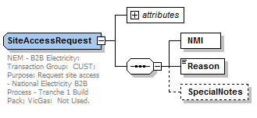

- Modify CustomerDetail complex type
  - Add EmailAddress as type EmailAddress
<xsd:complexType name="CustomerDetail">
<xsd:annotation>
<xsd:documentation>Purpose - Defines the customer details for notification</xsd:documentation>
</xsd:annotation>
<xsd:sequence>
<xsd:choice>
<xsd:element name="PersonName" type="PersonName"/>
<xsd:sequence>
<xsd:element name="BusinessName" type="BusinessName"/>
<xsd:element name="ContactName" type="PersonName" minOccurs="0" maxOccurs="unbounded"/>
</xsd:sequence>
</xsd:choice>
<xsd:element name="PostalAddress" type="Address" minOccurs="0"/>
<xsd:element name="PhoneNumber" type="AustralianPhoneNumber" minOccurs="0" maxOccurs="unbounded"/>
<xsd:element name="EmailAddress" type="EmailAddress" minOccurs="0" maxOccurs="unbounded"/>
<!-- xsd:element name="SpecialCondition" type="SpecialCondition" minOccurs="0"/ insert after phone number -->
</xsd:sequence>
</xsd:complexType>

- Change the version attribute of versioned type to r36:
- CutomerDetailsNotification complex type

Change from: xsd:attribute name="version" type="r32" use="optional" default="r32"/>
Change to: <xsd:attribute name="version" type="r36" use="optional" default="r36"/>

- Modify Product complex type
  - Remove limit on occurrances of Code element

<xsd:complexType name="Product">
<xsd:sequence>
<xsd:element name="Code" maxOccurs="unbounded">
<xsd:simpleType>
<xsd:restriction base="xsd:string">
<xsd:maxLength value="10"/>
</xsd:restriction>
</xsd:simpleType>
</xsd:element>
</xsd:sequence>
</xsd:complexType>

Electricity_r36.xsd
- Add EnergisationStatus simple type
<xsd:simpleType name="EnergisationStatus">
<xsd:annotation>
<xsd:documentation>
The energisation status of the metering installation
</xsd:documentation>
</xsd:annotation>
<xsd:restriction base="xsd:string">
<xsd:maxLength value="30"/>
<xsd:whiteSpace value="collapse"/>
</xsd:restriction>
</xsd:simpleType>

- Add GenerationType simple type (Max 5 string).
<xsd:simpleType name="GenerationType">
<xsd:annotation>
<xsd:documentation>
Indicates whether the meter is configured to measure the import of energy </xsd:documentation>
</xsd:annotation>
<xsd:restriction base="xsd:string">
<xsd:enumeration value="Net"/>
<xsd:enumeration value="Gross"/>
<xsd:enumeration value="None"/>
</xsd:restriction>
</xsd:simpleType>

- Add PrimaryVoltage simple type (Max 8 string).
<xsd:simpleType name="PrimaryVoltage">
<xsd:annotation>
<xsd:documentation>Indicates primary network voltage the metering installation is connected to</xsd:documentation>
</xsd:annotation>
<xsd:restriction base="xsd:string">
<xsd:maxLength value="8"/>
<xsd:minLength value="1"/>
<xsd:whiteSpace value="collapse"/>
</xsd:restriction>
</xsd:simpleType>

- Add DeviceLocation simple type
<xsd:simpleType name="DeviceLocation">
<xsd:restriction base="xsd:string">
<xsd:maxLength value="14"/>
</xsd:restriction>
</xsd:simpleType>

- Add DeviceSerialNumber simple type
<xsd:simpleType name="DeviceSerialNumber">
<xsd:restriction base="xsd:string">
<xsd:maxLength value="12"/>
</xsd:restriction>
</xsd:simpleType>

- Add ControlEquipmentSerialNumber simple type
<xsd:simpleType name="ControlEquipmentSerialNumber">
<xsd:restriction base="xsd:string">
<xsd:maxLength value="12"/>
</xsd:restriction>
</xsd:simpleType>

- Add ControlEquipmentType simple type
<xsd:simpleType name="ControlEquipmentType">
<xsd:restriction base="xsd:string">
<xsd:maxLength value="25"/>
<xsd:whiteSpace value="collapse"/>
</xsd:restriction>
</xsd:simpleType>

- Add ControlChannel simple type
<xsd:simpleType name="ControlChannel">
<xsd:restriction base="xsd:string">
<xsd:maxLength value="12"/>
</xsd:restriction>
</xsd:simpleType>

- Add InstrumentTransformerType simple type (Max 2 string).
<xsd:simpleType name="InstrumentTransformerType">
<xsd:annotation>
<xsd:documentation>Indicates instrument transformer type for the meter</xsd:documentation>
</xsd:annotation>
<xsd:restriction base="xsd:string">
<xsd:maxLength value="2"/>
<xsd:whiteSpace value="collapse"/>
</xsd:restriction>
</xsd:simpleType>

- Add InstrumentTransformerSerialNumber simple type
<xsd:simpleType name="InstrumentTransformerSerialNumber">
<xsd:restriction base="xsd:string">
<xsd:maxLength value="12"/>
</xsd:restriction>
</xsd:simpleType>

- Add De-energisationReason simple type
<xsd:simpleType name="De-energisationReason">
<xsd:annotation>
<xsd:documentation>
Purpose - Define the fixed Reasons used to request De-energisation
</xsd:documentation>
</xsd:annotation>
<xsd:restriction base="xsd:string">
<xsd:maxLength value="40"/>
</xsd:restriction>
</xsd:simpleType>

- Add SwitchingServiceRequired simple type
<xsd:simpleType name="SwitchingServiceRequired">
<xsd:restriction base="xsd:string">
<xsd:maxLength value="80"/>
</xsd:restriction>
</xsd:simpleType>

- Add RegisterIndexValue simple type

<xsd:simpleType name="RegisterIndexValue">
<xsd:annotation>
<xsd:documentation>
Purpose - Meter Register Index value as standalone.
</xsd:documentation>
</xsd:annotation>
<xsd:restriction base="xsd:string">
<xsd:maxLength value="15"/>
</xsd:restriction>
</xsd:simpleType>

- Add NetworkDevices complex type.
<xsd:complexType name="NetworkDevices">
<xsd:annotation>
<xsd:documentation>Purpose - Define the structure of Work details.</xsd:documentation>
</xsd:annotation>
<xsd:sequence>
<xsd:element name="NetworkDevice" type="NetworkDevice" maxOccurs="unbounded"/>
</xsd:sequence>
</xsd:complexType>
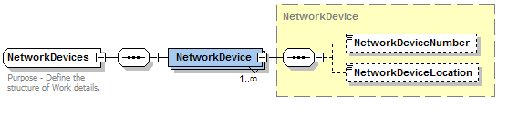
- Add NetworkDevice complex type.
<xsd:complexType name="NetworkDevice">
<xsd:annotation>
<xsd:documentation>Purpose - Define the structure network device detail.</xsd:documentation>
</xsd:annotation>
<xsd:sequence>
<xsd:element name="NetworkDeviceNumber" type="DeviceSerialNumber" minOccurs="0"/>
<xsd:element name="NetworkDeviceLocation" type="DeviceLocation" minOccurs="0"/>
</xsd:sequence>
</xsd:complexType>

- Add ControlEquipments complex type.
<xsd:complexType name="ControlEquipments">
<xsd:annotation>
<xsd:documentation>Purpose - Define the structure of Work details.</xsd:documentation>
</xsd:annotation>
<xsd:sequence>
<xsd:element name="ControlEquipment" type="ControlEquipment" maxOccurs="unbounded"/>
</xsd:sequence>
</xsd:complexType>
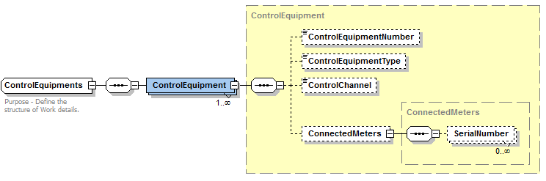
- Add ControlEquipment complex type.
<xsd:complexType name="ControlEquipment">
<xsd:annotation>
<xsd:documentation>Purpose - Define the structure of Control Equipment detail.</xsd:documentation>
</xsd:annotation>
<xsd:sequence>
<xsd:element name="ControlEquipmentNumber" type="ControlEquipmentSerialNumber" minOccurs="0"/>
<xsd:element name="ControlEquipmentType" type="ControlEquipmentType" minOccurs="0"/>
<xsd:element name="ControlChannel" type="ControlChannel" minOccurs="0"/>
<xsd:element name="ConnectedMeters" type="ConnectedMeters" minOccurs="0"/>
</xsd:sequence>
</xsd:complexType>

- Add InstrumentTransformers complex type.
<xsd:complexType name="InstrumentTransformers">
<xsd:annotation>
<xsd:documentation>Purpose - Define the structure of Work details.</xsd:documentation>
</xsd:annotation>
<xsd:sequence>
<xsd:element name="InstrumentTransformer" type="InstrumentTransformer" maxOccurs="unbounded"/>
</xsd:sequence>
</xsd:complexType>
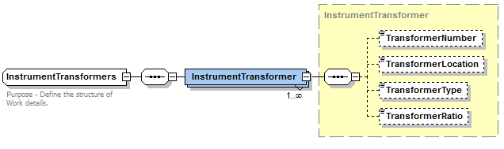
- Add InstrumentTransformer complex type.
<xsd:complexType name="InstrumentTransformer">
<xsd:annotation>
<xsd:documentation>Purpose - Define the structure of Control Equipment detail.</xsd:documentation>
</xsd:annotation>
<xsd:sequence>
<xsd:element name="TransformerNumber" type="InstrumentTransformerSerialNumber" minOccurs="0"/>

<xsd:element name="TransformerType" type="InstrumentTransformerType" minOccurs="0"/>
<xsd:element name="TransformerRatio" type="MeterTransformerRatio" minOccurs="0"/>
</xsd:sequence>
</xsd:complexType>

- Add ConnectedMeters complex type.
<xsd:complexType name="ConnectedMeters">
<xsd:annotation>
<xsd:documentation>Purpose - Define the structure of Control Equipment detail.</xsd:documentation>
</xsd:annotation>
<xsd:sequence>
<xsd:element name="SerialNumber" type="MeterSerialNumber" minOccurs="0" maxOccurs="unbounded"/>
</xsd:sequence>
</xsd:complexType>

- Modify ElectricityMeter complex type.
  - Add SupplyPhase element
  - Add GenerationType element
  - Add InstrumentTransformers element
  - Add GeneralSupply element
  - Add ControlEquipments element
<xsd:complexType name="ElectricityMeter">
<xsd:annotation>
<xsd:documentation>
Purpose - container for electricity meter information
</xsd:documentation>
</xsd:annotation>
<xsd:sequence>
<xsd:element name="SerialNumber" type="MeterSerialNumber" nillable="true" minOccurs="0"/>
<xsd:element name="NextScheduledReadDate" type="xsd:date" nillable="true" minOccurs="0"/>
<xsd:element name="Location" type="MeterLocation" nillable="true" minOccurs="0"/>
<xsd:element name="Hazard" type="MeterHazard" nillable="true" minOccurs="0"/>
<xsd:element name="InstallationTypeCode" type="MeterInstallationTypeCode" nillable="true" minOccurs="0"/>
<xsd:element name="Route" type="MeterRoute" nillable="true" minOccurs="0"/>
<xsd:element name="Use" type="MeterUse" nillable="true" minOccurs="0"/>
<xsd:element name="Point" type="MeterPoint" nillable="true" minOccurs="0"/>
<xsd:element name="Manufacturer" type="MeterManufacturer" nillable="true" minOccurs="0"/>
<xsd:element name="Model" type="MeterModel" nillable="true" minOccurs="0"/>
<xsd:element name="TransformerLocation" type="MeterTransformerLocation" nillable="true" minOccurs="0"/>
<xsd:element name="TransformerType" type="MeterTransformerType" nillable="true" minOccurs="0"/>
<xsd:element name="TransformerRatio" type="MeterTransformerRatio" nillable="true" minOccurs="0"/>
<xsd:element name="Constant" type="MeterConstant" nillable="true" minOccurs="0"/>
<xsd:element name="LastTestDate" type="xsd:date" nillable="true" minOccurs="0"/>
<xsd:element name="NextTestDate" type="xsd:date" nillable="true" minOccurs="0"/>
<xsd:element name="TestResultAccuracy" type="MeterTestResultAccuracy" nillable="true" minOccurs="0"/>
<xsd:element name="TestResultNotes" type="MeterTestResultNotes" nillable="true" minOccurs="0"/>
<xsd:element name="TestPerformedBy" type="MeterTestPerformedBy" nillable="true" minOccurs="0"/>
<xsd:element name="MeasurementType" type="MeterMeasurementType" nillable="true" minOccurs="0"/>
<xsd:element name="ReadTypeCode" type="MeterReadTypeCode" nillable="true" minOccurs="0"/>
<xsd:element name="RemotePhoneNumber" type="MeterRemotePhoneNumber" nillable="true" minOccurs="0"/>
<xsd:element name="CommunicationsEquipmentType" type="MeterCommunicationsEquipmentType" nillable="true" minOccurs="0"/>
<xsd:element name="CommunicationsProtocol" type="MeterCommunicationsProtocol" nillable="true" minOccurs="0"/>
<xsd:element name="DataConversion" type="MeterDataConversion" nillable="true" minOccurs="0"/>
<xsd:element name="DataValidations" type="MeterDataValidations" nillable="true" minOccurs="0"/>
<xsd:element name="Status" type="MeterStatusCode" minOccurs="0"/>
<xsd:element name="Program" type="MeterProgram" nillable="true" minOccurs="0"/>
<xsd:element name="AdditionalSiteInformation" type="MeterAdditionalSiteInformation" nillable="true" minOccurs="0"/>
<xsd:element name="EstimationInstructions" type="MeterEstimationInstructions" nillable="true" minOccurs="0"/>
<xsd:element name="AssetManagementPlan" type="MeterAssetManagementPlan" nillable="true" minOccurs="0"/>
<xsd:element name="CalibrationTables" type="MeterCalibrationTables" nillable="true" minOccurs="0"/>
<xsd:element name="UserAccessRights" type="MeterUserAccessRights" nillable="true" minOccurs="0"/>
<xsd:element name="Password" type="MeterPassword" nillable="true" minOccurs="0"/>
<xsd:element name="TestCalibrationProgram" type="MeterTestCalibrationProgram" nillable="true" minOccurs="0"/>
<xsd:element name="KeyCode" type="KeyCode" nillable="true" minOccurs="0"/>
<xsd:element name="CustomerFundedMeter" type="CustomerFundedMeter" nillable="true" minOccurs="0"/>
<xsd:element name="DisplayType" type="DisplayType" nillable="true" minOccurs="0"/>
<xsd:element name="SupplyPhase" type="SupplyPhase" minOccurs="0"/>
<xsd:element name="GenerationType" type="GenerationType" minOccurs="0"/>
<xsd:element name="GeneralSupply" type="YesNo" minOccurs="0"/>
<xsd:element name="InstrumentTransformers" type="InstrumentTransformers" minOccurs="0"/>
<xsd:element name="ControlEquipments" type="ControlEquipments" nillable="true" minOccurs="0"/>
<xsd:element name="RegisterConfiguration" type="ElectricityMeterRegisterConfiguration" nillable="true" minOccurs="0"/>
<xsd:element name="FromDate" type="xsd:date" minOccurs="0"/>
<xsd:element name="ToDate" type="xsd:date" minOccurs="0"/>
</xsd:sequence>
</xsd:complexType>

- Modify ElectricityServiceOrderDetails type (set to r36 version)
  - Add MeterLicense
  - Add De-energisationReason
  - Add LifeSupport
  - Add Co-ordinationRequired
  - Modify SwitchingServiceRequired to use SwitchingServiceRequired type, changing to varchar(80) from boolean.
<xsd:complexType name="ElectricityServiceOrderDetails">
<xsd:annotation>
<xsd:documentation>Purpose - Defines the data type for new connection and meter additions and alterations</xsd:documentation>
</xsd:annotation>
<xsd:complexContent>
<xsd:extension base="ServiceOrderRequestData">
<xsd:sequence>
<xsd:element name="CustomerConsultationRequired" type="xsd:boolean"/>
<xsd:element name="InstallationType" type="InstallationType" minOccurs="0"/>
<xsd:element name="SupplyPhase" type="SupplyPhase" minOccurs="0"/>
<xsd:element name="AverageDailyLoad" type="AveragedDailyLoad" minOccurs="0"/>
<xsd:element name="CustomerType" type="CustomerType" minOccurs="0"/>
<xsd:element name="MeteringType" type="MeteringType" minOccurs="0"/>
<xsd:element name="OffPeakRequirements" type="SpecialComments" minOccurs="0"/>
<xsd:element name="MaximumDemand" type="MeterDemand" minOccurs="0"/>
<xsd:element name="ServiceTime" type="ServiceTimeType" minOccurs="0"/>
<xsd:element name="SwitchingServiceRequired" type="SwitchingServiceRequired" minOccurs="0"/>
<xsd:element name="ConfirmedDe-energisation" type="xsd:boolean" minOccurs="0"/>
<xsd:element name="License" type="License" minOccurs="0"/>
<xsd:element name="MeterLicense" type="License" minOccurs="0"/>
<xsd:element name="De-energisationReason" type="De-energisationReason" minOccurs="0"/>
<xsd:element name="LifeSupport" type="YesNo"/>
<xsd:element name="Co-ordinationRequired" type="YesNo" minOccurs="0"/>
</xsd:sequence>
<xsd:attribute name="version" type="r36" use="optional" default="r36"/>
</xsd:extension>
</xsd:complexContent>
</xsd:complexType>
- Modify ElectricityMeterRegisterDetail
- Add RegisterIndexValue element as type RegisterIndexValue
<xsd:complexType name="ElectricityMeterRegisterDetail">
<xsd:annotation>
<xsd:documentation>
Purpose - container for information about a register within an electricity meter
</xsd:documentation>
</xsd:annotation>
<xsd:sequence>
<xsd:element name="RegisterID" type="MeterRegisterIdentifier" minOccurs="0"/>
<xsd:element name="NetworkTariffCode" type="NetworkTariffCode" nillable="true" minOccurs="0"/>
<xsd:element name="NetworkAdditionalInformation" type="MeterNetworkAdditionalInformation" nillable="true" minOccurs="0"/>
<xsd:element name="UnitOfMeasure" type="MeterUnitOfMeasure" nillable="true" minOccurs="0"/>
<xsd:element name="TimeOfDay" type="MeterTimeOfDay" nillable="true" minOccurs="0"/>
<xsd:element name="Multiplier" type="MeterMultiplier" nillable="true" minOccurs="0"/>
<xsd:element name="DialFormat" type="MeterDialFormat" nillable="true" minOccurs="0"/>
<xsd:element name="Suffix" type="NMIDataStreamSuffix" nillable="true" minOccurs="0"/>
<xsd:element name="ControlledLoad" type="MeterControlledLoad" nillable="true" minOccurs="0"/>
<xsd:element name="ConsumptionType" type="MeterConsumptionType" nillable="true" minOccurs="0"/>
<xsd:element name="Demand1" type="MeterDemand" nillable="true" minOccurs="0"/>
<xsd:element name="Demand2" type="MeterDemand" nillable="true" minOccurs="0"/>
<xsd:element name="Status" type="MeterRegisterStatusCode" nillable="true" minOccurs="0"/>
<xsd:element name="DirectionIndicator" type="DirectionIndicator" nillable="true" minOccurs="0"/>
<xsd:element name="PreviousReading" type="ElectricityMeterReadData" nillable="true" minOccurs="0"/>
<xsd:element name="HighLowConsumption" type="HighLowConsumption" nillable="true" minOccurs="0"/>
<xsd:element name="RegisterIndexValue" type="RegisterIndexValue" nillable="true" minOccurs="0"/>
<xsd:element name="FromDate" type="xsd:date" minOccurs="0"/>
<xsd:element name="ToDate" type="xsd:date" minOccurs="0"/>
</xsd:sequence>
</xsd:complexType>

- Modify ServiceOrderType to add enumerated values
- Supply Service Works
- Metering Service Works
- Modify ServiceOrderType to remove redundant enumerated values
- New Connection
- Adds And Alts
- Allocate NMI
- Supply Abolishment
- Meter Investigation
- Metering Reconfiguration

<xsd:simpleType name="ServiceOrderType">
<xsd:annotation>
<xsd:documentation>Purpose - Defines a list of valid Service Order types supported by the particpants</xsd:documentation>
</xsd:annotation>
<xsd:restriction base="xsd:string">
<xsd:enumeration value="Allocate NMI"/>
<xsd:enumeration value="New Connection"/>
<xsd:enumeration value="Re-energisation"/>
<xsd:enumeration value="De-energisation"/>
<xsd:enumeration value="Special Read"/>
<xsd:enumeration value="Adds And Alts"/>
<xsd:enumeration value="Meter Reconfiguration"/>
<xsd:enumeration value="Meter Investigation"/>
<xsd:enumeration value="Supply Abolishment"/>
<xsd:enumeration value="Miscellaneous"/>
<xsd:enumeration value="Metering Service Works"/>
<xsd:enumeration value="Supply Service Works"/>
</xsd:restriction>
</xsd:simpleType>

- Modify ServiceOrderSubType to add enumerated values
- Allocate NMI
- Change Timeswitch Settings
- Disconnect at Pillar-Box Pit Or Pole-Top
- Establish Permanent Supply
- Establish Temporary In Permanent
- Establish Temporary Supply
- Local Meter Disconnect
- Meter Investigation-Inspect
- Meter Investigation-Test
- Meter Reconfiguration
- Move-in
- Physical Visit
- Recipient Discretion
- Remote
- Reseal Device
- Supply Abolishment
- Supply Alteration
- Tariff Change
- Temporary Isolation
- Temporary Isolation-Group Supply
- Modify ServiceOrderSubType to remove redundant enumeration values
- Change Controlled Load
- Change Tariff
- Change Timeswitch
- Inspect
- Install Hot Water
- Lab Test
- Meter Test
- Onsite Test
- Permanent
- Pillar-Box Pit Or Pole-Top
- Pillar-Box Pit Or Pole-Top (Non-Payment)
- Remove Fuse (Non-Payment)
- Sticker
- Tamper
- Temporary
- Temporary in Permanent
- Warning

<xsd:simpleType name="ServiceOrderSubType">
<xsd:annotation>
<xsd:documentation>Purpose - Defines a list of valid Service Order types supported by the particpants</xsd:documentation>
</xsd:annotation>
<xsd:restriction base="xsd:string">
<xsd:enumeration value="Temporary"/>
<xsd:enumeration value="Temporary in Permanent"/>
<xsd:enumeration value="Permanent"/>
<xsd:enumeration value="Sticker Removal"/>
<xsd:enumeration value="New Reading Required"/>
<xsd:enumeration value="Warning"/>
<xsd:enumeration value="Remove Fuse (Non-Payment)"/>
<xsd:enumeration value="Pillar-Box Pit Or Pole-Top"/>
<xsd:enumeration value="Pillar-Box Pit Or Pole-Top (Non-Payment)"/>
<xsd:enumeration value="Sticker"/>
<xsd:enumeration value="Install Hot Water"/>
<xsd:enumeration value="Change Controlled Load"/>
<xsd:enumeration value="Change Timeswitch"/>
<xsd:enumeration value="Change Tariff"/>
<xsd:enumeration value="Tamper"/>
<xsd:enumeration value="Inspect"/>
<xsd:enumeration value="Onsite Test"/>
<xsd:enumeration value="Lab Test"/>
<xsd:enumeration value="Meter Test"/>
<xsd:enumeration value="After Disconnection For Non-Payment"/>
<xsd:enumeration value="Remove Fuse"/>
<xsd:enumeration value="Disconnect at Pillar-Box Pit Or Pole-Top"/>
<xsd:enumeration value="Install Controlled Load"/>
<xsd:enumeration value="Move Meter"/>
<xsd:enumeration value="Install Meter"/>
<xsd:enumeration value="Remove Meter"/>
<xsd:enumeration value="Exchange Meter"/>
<xsd:enumeration value="Check Read"/>
<xsd:enumeration value="Final Read"/>
<xsd:enumeration value="Allocate NMI"/>
<xsd:enumeration value="Establish Permanent Supply"/>
<xsd:enumeration value="Establish Temporary Supply"/>
<xsd:enumeration value="Establish Temporary In Permanent"/>
<xsd:enumeration value="Local Meter Disconnection"/>
<xsd:enumeration value="Meter Investigation-Inspect"/>
<xsd:enumeration value="Meter Investigation-Test"/>
<xsd:enumeration value="Meter Reconfiguration"/>
<xsd:enumeration value="Recipient Discretion"/>
<xsd:enumeration value="Remote"/>
<xsd:enumeration value="Supply Abolishment"/>
<xsd:enumeration value="Supply Alteration"/>
<xsd:enumeration value="Tariff Change"/>
<xsd:enumeration value="Temporary Isolation"/>
<xsd:enumeration value="Temporary Isolation-Group Supply"/>
<xsd:enumeration value="Change Timeswitch Settings"/>
<xsd:enumeration value="Reseal Device"/>
<xsd:enumeration value="Retrospective Move-in"/>
<xsd:enumeration value="Move-in"/>
<xsd:enumeration value="New Reading Required"/>
<xsd:enumeration value="Physical Visit"/>

</xsd:restriction>
</xsd:simpleType>

- Modify SORDResponseCode to add enumerated values
- Tariff Change Not Approved
- Inadequate infrastructure
- No infrastructure
- Life Support
- Request Submitted By Another Initiator
- Initiator Cancellation
- Recipient Cancellation
- Modify SORDResponseCode to remove enumerated values
- Retailer Cancellation
- Service Provider Cancellation
- Request Submitted By Another Retailer

<xsd:simpleType name="SORDResponseCode">
<xsd:annotation>
<xsd:documentation>Purpose - Defines a list of valid response code for different types of service orders</xsd:documentation>
</xsd:annotation>
<xsd:restriction base="xsd:string">
<xsd:enumeration value="Customer On-Site"/>
<xsd:enumeration value="Customer Prevented"/>
<xsd:enumeration value="De-energisation Not Completed Due To A Re-energisation"/>
<xsd:enumeration value="Documentation Not Provided"/>
<xsd:enumeration value="Metering Problem"/>
<xsd:enumeration value="Meter Reading Only Undertaken Due To Prior Re-energisation"/>
<xsd:enumeration value="New Customer On-Site"/>
<xsd:enumeration value="No Supply"/>
<xsd:enumeration value="Other"/>
<xsd:enumeration value="Reading Problem"/>
<xsd:enumeration value="Request Submitted By Another Initiator"/>
<xsd:enumeration value="Initiator Cancellation"/>
<xsd:enumeration value="Sensitive Load"/>
<xsd:enumeration value="Recipient Cancellation"/>
<xsd:enumeration value="Unable To Access"/>
<xsd:enumeration value="Unknown Load"/>
<xsd:enumeration value="Unsafe"/>
<xsd:enumeration value="Tariff Change Not Approved"/>
<xsd:enumeration value="Inadequate infrastructure"/>
<xsd:enumeration value="No Comms"/>
<xsd:enumeration value="Life Support"/>
<xsd:enumeration value="Meter Not Retrieved"/>
<xsd:enumeration value="Metering not compatible with proposed Tariff Change"/>
<xsd:enumeration value="Shared Supply Point"/>
<xsd:enumeration value="Site Already Energised"/>
<xsd:enumeration value="Unknown Connection Status"/>
</xsd:restriction>
</xsd:simpleType>

- Modify SupplyPhase to add enumerated values
- Unknown

- Modify MeteringType to remove enumerated list
<xsd:simpleType name="MeteringType">
<xsd:restriction base="xsd:string">
<xsd:maxLength value="240"/>
</xsd:restriction>
</xsd:simpleType>

Modify ElectricityStandingData (set to r36 version)
Change from: xsd:attribute name="version" type="r35" use="optional" default="r35"/>
Change to: <xsd:attribute name="version" type="r36" use="optional" default="r36"/>

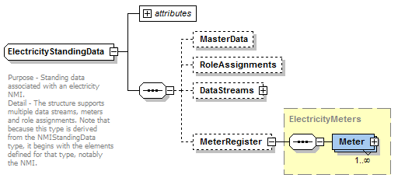
Modify ElectricityServiceOrderNotificationData (set to r36 version)
Change from: xsd:attribute name="version" type="r17" use="optional" default="r17"/>
Change to: <xsd:attribute name="version" type="r36" use="optional" default="r36"/>

Modify ElectricityServiceOrderType (set to r36 version)
Change from: xsd:attribute name="version" type="r19" use="optional" default="r19"/>
Change to: <xsd:attribute name="version" type="r36" use="optional" default="r36"/>

ElectricityMasterStandingData_r36.xsd
- Modify ElectricityMasterStandingData complex type:
- Add EnergisationStatus element
- Add PrimaryVoltage element
- Add ControlEquipments element
- Add NetworkDevices element
<xsd:complexType name="ElectricityMasterStandingData">
<xsd:annotation>
<xsd:documentation>
Purpose - container for non-repeating standing data associated with an electricity NMI
</xsd:documentation>
</xsd:annotation>
<xsd:sequence>
<xsd:element name="JurisdictionCode" type="JurisdictionCode" nillable="true" minOccurs="0"/>
<xsd:element name="NMIClassificationCode" type="NMIClassificationCode" nillable="true" minOccurs="0"/>
<xsd:element name="TransmissionNodeIdentifier" type="TransmissionNodeIdentifier" nillable="true" minOccurs="0"/>
<xsd:element name="DistributionLossFactorCode" type="DistributionLossFactorCode" nillable="true" minOccurs="0"/>
<xsd:element name="ParentEmbeddedNetworkIdentifier" type="EmbeddedNetworkIdentifier" nillable="true" minOccurs="0"/>
<xsd:element name="ChildEmbeddedNetworkIdentifier" type="EmbeddedNetworkIdentifier" nillable="true" minOccurs="0"/>
<xsd:element name="Address" type="AustralianPartialAddress" nillable="true" minOccurs="0"/>
<xsd:element name="Aggregate" type="YesNo" nillable="true" minOccurs="0"/>
<xsd:element name="Status" type="NMIStatusCode" nillable="true" minOccurs="0"/>
<xsd:element name="DistanceFromSubstation" type="DistanceFromSubstation" nillable="true" minOccurs="0"/>
<xsd:element name="VoltageType" type="VoltageType" nillable="true" minOccurs="0"/>
<xsd:element name="PoleNumber" type="PoleNumber" nillable="true" minOccurs="0"/>
<xsd:element name="AccessDetails" type="AccessDetail" nillable="true" minOccurs="0"/>
<xsd:element name="FeederClass" type="FeederClass" nillable="true" minOccurs="0"/>
<xsd:element name="CustomerClassificationCode" type="EMSDCustomerClassificationCode" nillable="true" minOccurs="0"/>
<xsd:element name="CustomerThresholdCode" type="EMSDCustomerThresholdCode" nillable="true" minOccurs="0"/>
<xsd:element name="ControlEquipments" type="ControlEquipments" nillable="true" minOccurs="0"/>
<xsd:element name="NetworkDevices" type="NetworkDevices" nillable="true" minOccurs="0"/>
<xsd:element name="EnergisationStatus" type="EnergisationStatus" nillable="true" minOccurs="0"/>
<xsd:element name="PrimaryVoltage" type="PrimaryVoltage" nillable="true" minOccurs="0"/>
<xsd:element name="FromDate" type="xsd:date" minOccurs="0"/>
<xsd:element name="ToDate" type="xsd:date" minOccurs="0"/>
</xsd:sequence>
</xsd:complexType>

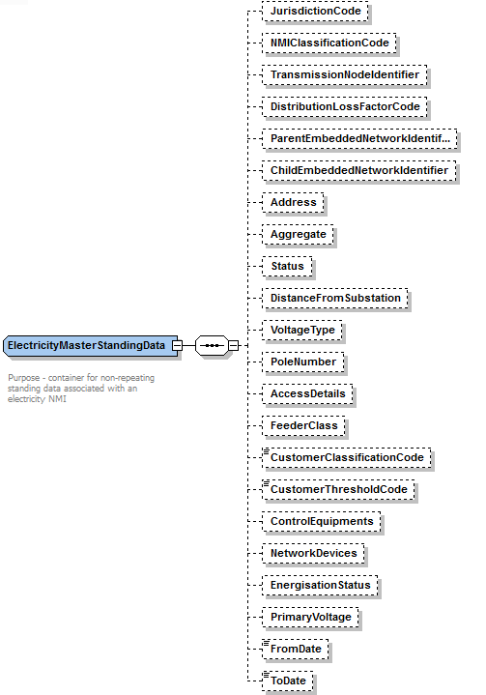

MeterDataManagement_r36.xsd
- Add ResponseFormat simple type.
<xsd:simpleType name="ResponseFormat">
<xsd:annotation>
<xsd:documentation>This element is used to define the Response payload format. eg CSV, XML, MDFF, BASE64</xsd:documentation>
</xsd:annotation>
<xsd:restriction base="xsd:string">
<xsd:maxLength value="20"/>
</xsd:restriction>
</xsd:simpleType>

- Add RemoteServiceType simple type.
<xsd:simpleType name="RemoteServiceType">
<xsd:annotation>
<xsd:documentation>This element is used to define the RemoteService Type.</xsd:documentation>
</xsd:annotation>
<xsd:restriction base="xsd:string">
<xsd:maxLength value="40"/>
</xsd:restriction>
</xsd:simpleType>

- Add RemoteServiceRequestCode simple type.
<xsd:simpleType name="RemoteServiceRequestCode">
<xsd:annotation>
<xsd:documentation>This element is used to define the RemoteServiceRequest code.</xsd:documentation>
</xsd:annotation>
<xsd:restriction base="xsd:string">
<xsd:maxLength value="40"/>
</xsd:restriction>
</xsd:simpleType>

- Add UserDefinition simple type.
<xsd:simpleType name="UserDefinition">
<xsd:annotation>
<xsd:documentation>This element is used to define the User definitions as agreed between initiator and recipient.</xsd:documentation>
</xsd:annotation>
<xsd:restriction base="xsd:string">
<xsd:maxLength value="240"/>
</xsd:restriction>
</xsd:simpleType>

- Add ServiceRequestID simple type.
<xsd:simpleType name="ServiceRequestID">
<xsd:annotation>
<xsd:documentation>This element is used to define the Remote service request ID.</xsd:documentation>
</xsd:annotation>
<xsd:restriction base="xsd:string">
<xsd:maxLength value="15"/>
</xsd:restriction>
</xsd:simpleType>

- Add ResponsePayload complex type.
<xsd:complexType name="ResponsePayload">
<xsd:sequence>
<xsd:element name="RecordCount" type="RecordCount" minOccurs="0"/>
<xsd:element name="PayloadContent" type="xsd:anyType" nillable="true"/>
</xsd:sequence>
</xsd:complexType>

- Add MeterSerialNumbers complex type.
<xsd:complexType name="MeterSerialNumbers">
<xsd:annotation>
<xsd:documentation>Schema - RemoteService. Collection of affected Meters</xsd:documentation>
</xsd:annotation>
<xsd:sequence>
<xsd:element name="MeterSerialNumber" type="MeterSerialNumber" maxOccurs="unbounded"/>
</xsd:sequence>
</xsd:complexType>

- Add UserDefData complex type.
<xsd:complexType name="UserDefData">
<xsd:annotation>
<xsd:documentation>Schema - RemoteService. User definitions block</xsd:documentation>
</xsd:annotation>
<xsd:sequence>
<xsd:element name="UserDef1" type="UserDefinition" minOccurs="0"/>
<xsd:element name="UserDef2" type="UserDefinition" minOccurs="0"/>
<xsd:element name="UserDef3" type="UserDefinition" minOccurs="0"/>
<xsd:element name="UserDef4" type="UserDefinition" minOccurs="0"/>
<xsd:element name="UserDef5" type="UserDefinition" minOccurs="0"/>
<xsd:element name="UserDef6" type="UserDefinition" minOccurs="0"/>
<xsd:element name="UserDef7" type="UserDefinition" minOccurs="0"/>
<xsd:element name="UserDef8" type="UserDefinition" minOccurs="0"/>
<xsd:element name="UserDef9" type="UserDefinition" minOccurs="0"/>
<xsd:element name="UserDef10" type="UserDefinition" minOccurs="0"/>
</xsd:sequence>
</xsd:complexType>

- Add RemoteServiceData complex type.
<xsd:complexType name="RemoteServiceData">
<xsd:annotation>
<xsd:documentation>Schema - RemoteService</xsd:documentation>
</xsd:annotation>
<xsd:sequence>
<xsd:element name="RequestID" type="ServiceRequestID"/>
<xsd:element name="NMI" type="NMI"/>
<xsd:element name="Meters" type="MeterSerialNumbers"/>
<xsd:element name="ServiceType" type="RemoteServiceType"/>
<xsd:element name="RequestCode" type="RemoteServiceRequestCode"/>
<xsd:element name="ResponseFormat" type="ResponseFormat"/>
<xsd:element name="FromDateTime" type="xsd:dateTime" minOccurs="0"/>
<xsd:element name="ToDateTime" type="xsd:dateTime" minOccurs="0"/>
<xsd:element name="UserDef" type="UserDefData" minOccurs="0"/>
</xsd:sequence>
</xsd:complexType>

- Add RemoteServiceResponseData complex type.
<xsd:complexType name="RemoteServiceResponseData">
<xsd:annotation>
<xsd:documentation>Schema - ServiceOrder</xsd:documentation>
</xsd:annotation>
<xsd:sequence>
<xsd:element name="ResponsePayload" type="ResponsePayload" minOccurs="0"/>
<xsd:element name="Event" type="Event" minOccurs="0"/>
<xsd:element name="Product" type="Product" minOccurs="0"/>
</xsd:sequence>
</xsd:complexType>

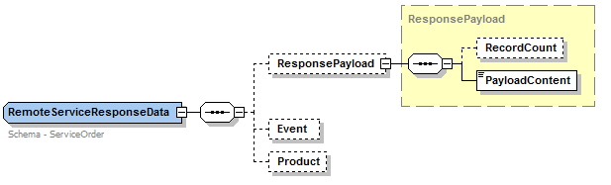

- Add RemoteServiceRequest complex type as new transaction
<xsd:complexType name="RemoteServiceRequest">
<xsd:annotation>
<xsd:documentation>Prior to commencing the use of the Remote Service Process the Initiator and Recipient must agree the scope of the service(s) and the format of the response to the service request.
</xsd:documentation>
</xsd:annotation>
<xsd:sequence>
<xsd:element name="RemoteServiceData" type="RemoteServiceData"/>
</xsd:sequence>
<xsd:attribute name="version" type="r36" use="optional" default="r36"/>
</xsd:complexType>
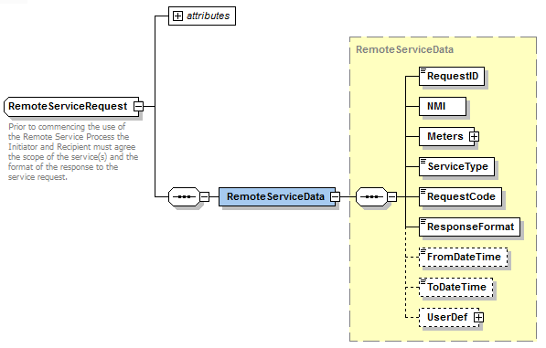
- Add RemoteServiceResponse complex type as new transaction\
<xsd:complexType name="RemoteServiceResponse">
<xsd:annotation>
<xsd:documentation>Prior to commencing the use of the Remote Service Process the Initiator and Recipient must agree the scope of the service(s) and the format of the response to the service request.
</xsd:documentation>
</xsd:annotation>
<xsd:sequence>
<xsd:element name="RemoteServiceData" type="RemoteServiceData"/>
<xsd:element name="ResponseData" type="RemoteServiceResponseData"/>
</xsd:sequence>
<xsd:attribute name="version" type="r36" use="optional" default="r36"/>
</xsd:complexType>
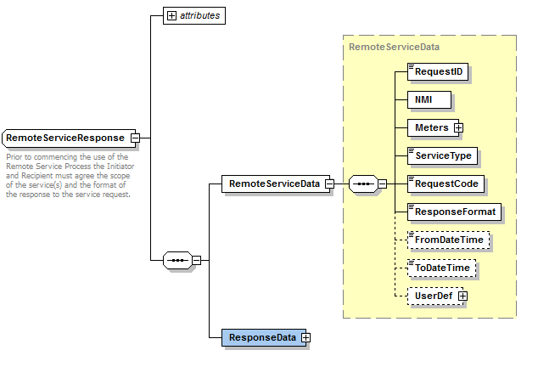

Common_r34.xsd
- Add Latitude simple type.
<xsd:simpleType name="Latitude">
<xsd:annotation>
<xsd:documentation>
Purpose - Provide geographic location coordinate.
Detail - Geographic latitude
The angular measurement North or South of the equator in decimal degrees (to 7 decimal places). Angles South of the equator will be represented as negative values. Eg -37.8886755
</xsd:documentation>
</xsd:annotation>
<xsd:restriction base="xsd:decimal">
<xsd:totalDigits value="9"/>
<xsd:fractionDigits value="7"/>
</xsd:restriction>
</xsd:simpleType>

- Add Longitude simple type
<xsd:simpleType name="Longitude">
<xsd:annotation>
<xsd:documentation>
Purpose – Provide geographic location coordinate.
Detail - Geographic longitude
The angular measurement East or West of the prime meridian in decimal degrees (to 7 decimal places). Angles East of the Prime Meridian (eg Australia) will be represented as positive values. Eg +145.1410361
</xsd:documentation>
</xsd:annotation>
<xsd:restriction base="xsd:decimal">
<xsd:totalDigits value="10"/>
<xsd:fractionDigits value="7"/> </xsd:restriction>
</xsd:simpleType>
- Add complex type GeographicCoordinate
<xsd:complexType name="GeographicCoordinate">
<xsd:annotation>
<xsd:documentation>
Purpose - Coordinates specification</xsd:documentation>
</xsd:annotation>
<xsd:sequence>
<xsd:element name="Latitude" type="Latitude"/>
<xsd:element name="Longitude" type="Longitude"/>
</xsd:sequence>
</xsd:complexType>

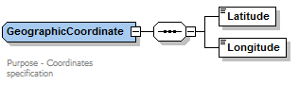

- Add NotifiedParties complex type.
<xsd:complexType name="NotifiedParties">
<xsd:annotation>
<xsd:documentation>
Purpose - List Notified parties</xsd:documentation>
</xsd:annotation>
<xsd:sequence>
<xsd:element name="NotifiedPartyID" type="PartyIdentifier" minOccurs="0" maxOccurs="unbounded"/>
</xsd:sequence>
</xsd:complexType>
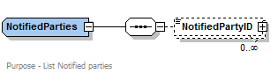

- Modify IndexInvestigationCode simple type by adding enumeration values:
- Verify/Missing Registers
- Require Estimate Read
- Meter Churn
<xsd:simpleType name="IndexInvestigationCode">
<xsd:annotation>
<xsd:documentation>Schema - Gas</xsd:documentation>
</xsd:annotation>
<xsd:restriction base="xsd:string">
<xsd:enumeration value="Confirm Reading For Vacant Site"/>
<xsd:enumeration value="Confirm Zero Consumption"/>
<xsd:enumeration value="Incomplete Data"/>
<xsd:enumeration value="Invalid MDFF Data"/>
<xsd:enumeration value="Invalid Standing Data"/>
<xsd:enumeration value="Missing Datastream"/>
<xsd:enumeration value="Require Actual Reading or Substitute"/>
<xsd:enumeration value="Require Final Substitute"/>
<xsd:enumeration value="Require Latest Version"/>
<xsd:enumeration value="Scheduled Reading Required"/>
<xsd:enumeration value="Service Order Reading Required"/>
<xsd:enumeration value="Verify High Reading"/>
<xsd:enumeration value="Verify Low Reading"/>
<xsd:enumeration value="Customer Away"/>
<xsd:enumeration value="Customer Query"/>
<xsd:enumeration value="Customer Read"/>
<xsd:enumeration value="High Account"/>
<xsd:enumeration value="Zero Consumption"/>
<xsd:enumeration value="Recipient Not Responsible For The NMI"/>
<xsd:enumeration value="Other"/>
<xsd:enumeration value="Cross Meter"/>
<xsd:enumeration value="MDL Out of Alignment"/>
<xsd:enumeration value="Verify/Missing Register"/>
<xsd:enumeration value="Require Estimate Data"/>
<xsd:enumeration value="Meter Churn"/>
</xsd:restriction>
</xsd:simpleType>

OneWayNotification_r33.xsd
- Add NoticeOfWorksID simple type as string.
<xsd:simpleType name="NoticeOfWorksID">
<xsd:restriction base="xsd:string">
<xsd:maxLength value="12"/>
</xsd:restriction>
</xsd:simpleType>

- Add NotificationNotes simple type as string
<xsd:simpleType name="NotificationNotes">
<xsd:restriction base="xsd:string">
<xsd:maxLength value="240"/>
</xsd:restriction>
</xsd:simpleType>
- Add NotificationStatus simple type as string
<xsd:simpleType name="NotificationStatus">
<xsd:restriction base="xsd:string">
<xsd:maxLength value="30"/>
</xsd:restriction>
</xsd:simpleType>

- Add WorkType simple type as string.
<xsd:simpleType name="WorkType">
<xsd:restriction base="xsd:string">
<xsd:maxLength value="50"/>
</xsd:restriction>
</xsd:simpleType>
- Add ReasonForInter simple type as string
<xsd:simpleType name="ReasonForInter">
<xsd:restriction base="xsd:string">
<xsd:maxLength value="50"/>
</xsd:restriction>
</xsd:simpleType>
- Add ReasonForNotice simple type as string
<xsd:simpleType name="ReasonForNotice">
<xsd:restriction base="xsd:string">
<xsd:maxLength value="50"/>
</xsd:restriction>
</xsd:simpleType>

- Add SupplyOff simple type as string
<xsd:simpleType name="SupplyOff">
<xsd:restriction base="xsd:string">
<xsd:maxLength value="40"/>
</xsd:restriction>
</xsd:simpleType>

- Add Duration simple type as string
<xsd:simpleType name="Duration">
<xsd:restriction base="xsd:string">
<xsd:maxLength value="5"/>
</xsd:restriction>
</xsd:simpleType>

- Add RemovedMeteringEquipments complex type
<xsd:complexType name="RemovedMeteringEquipments">
<xsd:annotation>
<xsd:documentation>Purpose - Define the structure of Work details.</xsd:documentation>
</xsd:annotation>
<xsd:sequence>
<xsd:element name="RemovedMeteringEquipment" type="RemovedMeteringEquipment" maxOccurs="unbounded"/>
</xsd:sequence>
</xsd:complexType>

- Add RemovedMeteringEquipment complex type
<xsd:complexType name="RemovedMeteringEquipment">
<xsd:annotation>
<xsd:documentation>Purpose - Define the structure of removed equipment.</xsd:documentation>
</xsd:annotation>
<xsd:sequence>
<xsd:element name="RemovedEquipmentType" type="MeterEquipmentType"/>
<xsd:element name="MeteringEquipment" type="NMIStandingData"/>
</xsd:sequence>
</xsd:complexType>
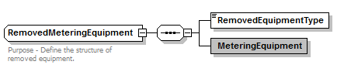
- Add NewEquipment complex type
<xsd:complexType name="NewEquipment">
<xsd:annotation>
<xsd:documentation>Purpose - Define the structure of Work details.</xsd:documentation>
</xsd:annotation>
<xsd:sequence>
<xsd:element name="InstalledMeterEquipment" type="ElectricityMeters" minOccurs="0"/>
<xsd:element name="InstalledNetworkDevices" type="NetworkDevices" minOccurs="0"/>
<xsd:element name="InstalledControlEquipment" type="NMIStandingData" minOccurs="0"/>
<xsd:element name="InstalledTransformers" type="ElectricityMeters" minOccurs="0"/>
</xsd:sequence>
</xsd:complexType>
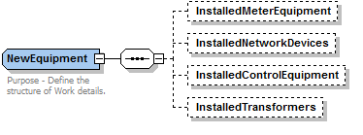

- Add WorksDetail complex type
<xsd:complexType name="WorksDetail">
<xsd:annotation>
<xsd:documentation>Purpose - Define the structure of Work details.</xsd:documentation>
</xsd:annotation>
<xsd:sequence>
<xsd:element name="WorkType" type="WorkType"/>
<xsd:element name="FieldWorkCompleteDateTime" type="xsd:dateTime"/>
<xsd:element name="TotalInstalledMeters" type="xsd:integer" minOccurs="0"/>
<xsd:element name="TotalInstalledNetworkDevices" type="xsd:integer" minOccurs="0"/>
<xsd:element name="TotalInstalledControlEquipment" type="xsd:integer" minOccurs="0"/>
<xsd:element name="TotalInstalledTransformers" type="xsd:integer" minOccurs="0"/>
<xsd:element name="TotalRemovedMeters" type="xsd:integer" minOccurs="0"/>
<xsd:element name="TotalRemovedOther" type="xsd:integer" minOccurs="0"/>
<xsd:element name="NewMeterEquipment" type="NewEquipment" minOccurs="0"/>
<xsd:element name="RemovedMeteringEquipments" type="RemovedMeteringEquipments" minOccurs="0"/>
</xsd:sequence>
</xsd:complexType>
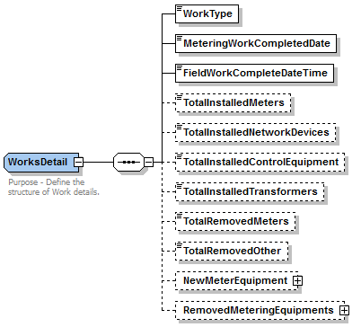

- Add NotificationPayload complex type.
<xsd:complexType name="NotificationPayload">
<xsd:annotation>
<xsd:documentation>Purpose - Define the structure of Work details.</xsd:documentation>
</xsd:annotation>
<xsd:sequence>
<xsd:choice>
<xsd:element name="TransactionNotified" type="Transaction"/>
<xsd:element name="TransAckNotified" type="TransactionAcknowledgement"/>
<xsd:element name="MsgAckNotified" type="MessageAcknowledgement"/>
</xsd:choice>
</xsd:sequence>
</xsd:complexType>
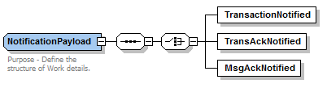

- Add NoticeOfMeteringWorks complex type as new transaction.
<xsd:complexType name="NoticeOfMeteringWorks">
<xsd:sequence>
<xsd:element name="NoticeOfWorksID" type="NoticeOfWorksID"/>
<xsd:element name="NMIStandingData" type="NMIStandingData"/>
<xsd:element name="GeographicCoordinate" type="GeographicCoordinate" minOccurs="0"/>
<xsd:element name="MeterWorksDetail" type="WorksDetail"/>
<xsd:element name="Notes" type="NotificationNotes" minOccurs="0"/>
</xsd:sequence>
<xsd:attribute name="version" type="r36" use="optional" default="r36"/>
</xsd:complexType>
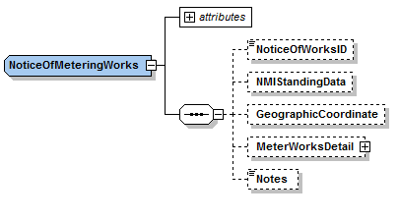

- Add NotifiedParty complex type as new transaction.
<xsd:complexType name="NotifiedParty">
<xsd:sequence>
<xsd:element name="ServiceOrder" type="ServiceOrderHeader"/>
<xsd:element name="ServiceRequestor" type="PartyIdentifier"/>
<xsd:element name="ServiceProvider" type="PartyIdentifier"/>
<xsd:element name="ScheduledDate" type="xsd:date"/>
<xsd:element name="ActualDateTime" type="xsd:dateTime" minOccurs="0"/>
<xsd:element name="NotificationStatus" type="NotificationStatus"/>
<xsd:element name="RefTransaction" type="NotificationPayload"/>
</xsd:sequence>
<xsd:attribute name="version" type="r36" use="optional" default="r36"/>
</xsd:complexType>
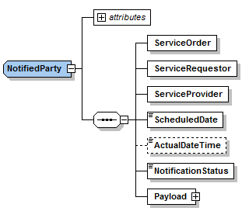

- Add PlannedInterruptionNotification complex type as new transaction.
<xsd:complexType name="PlannedInterruptionNotification">
<xsd:sequence>
<xsd:element name="NMI" type="NMI"/>
<xsd:element name="StartDate" type="xsd:date"/>
<xsd:element name="StartTime" type="xsd:time"/>
<xsd:element name="EndDate" type="xsd:date" minOccurs="0"/>
<xsd:element name="Duration" type="Duration"/
<xsd:element name="ReasonForInter" type="ReasonForInter" minOccurs="0"/>
<xsd:element name="Notes" type="NotificationNotes" minOccurs="0"/>
</xsd:sequence>
<xsd:attribute name="version" type="r36" use="optional" default="r36"/>
</xsd:complexType>
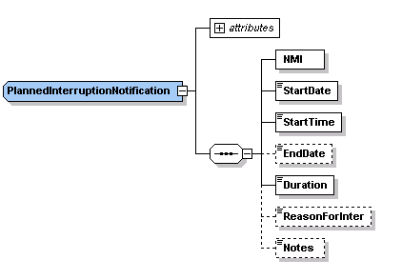
- Add MeterFaultAndIssueNotification complex type as new transaction.
<xsd:complexType name="MeterFaultAndIssueNotification">
<xsd:sequence>
<xsd:element name="NMI" type="NMI"/>
<xsd:element name="DateIdentified" type="xsd:date"/>
<xsd:element name="StartDate" type="xsd:date" minOccurs="0"/>
<xsd:element name="StartTime" type="xsd:time" minOccurs="0"/>
<xsd:element name="EndDate" type="xsd:date" minOccurs="0"/>
<xsd:element name="Duration" type="Duration" minOccurs="0"/>
<xsd:element name="SupplyOn" type="YesNo"/>
<xsd:element name="SupplyOff" type="SupplyOff" minOccurs="0"/>
<xsd:element name="Meters" type="ElectricityMeters" minOccurs="0"/>
<xsd:element name="ReasonForNotice" type="ReasonForNotice"/>
<xsd:element name="Notes" type="NotificationNotes" minOccurs="0"/>
</xsd:sequence>
<xsd:attribute name="version" type="r36" use="optional" default="r36"/>
</xsd:complexType>
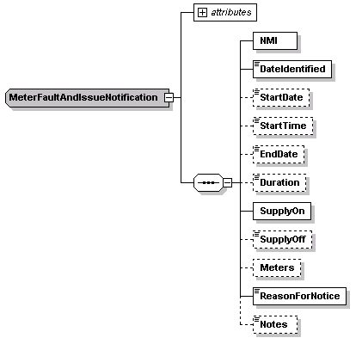

ServiceOrder_r33.xsd

- Modify ServiceOrderRequest complex type (set to r36 version)
  - Add NotifiedParties element
  - Add Co-ordinatingContactDetail element
<xsd:complexType name="ServiceOrderRequest">
<xsd:annotation>
<xsd:documentation>
Application - Service Order
TransactionExchange -
TransactionGroup - SORD
Priority - Medium
Purpose - Submit Service Order Request to the Service Provider
</xsd:documentation>
</xsd:annotation>
<xsd:sequence>
<xsd:element name="ServiceOrder" type="ServiceOrderHeader"/>
<xsd:element name="ServicePoint" type="ServicePoint" minOccurs="0"/>
<xsd:element name="ContactDetail" type="CustomerDetail" minOccurs="0"/>
<xsd:element name="CustomerDetail" type="CustomerDetail" minOccurs="0"/>
<xsd:element name="Co-ordinatingContactDetail" type="CustomerDetail" minOccurs="0"/>
<xsd:element name="AppointmentDetail" type="AppointmentDetail" minOccurs="0"/>
<xsd:element name="RequestData" type="ServiceOrderRequestData" minOccurs="0"/>
<xsd:element name="NotifiedParties" type="NotifiedParties" minOccurs="0"/>
</xsd:sequence>
<xsd:attribute name="version" type="r36" use="optional" default="r36"/>
<xsd:attribute name="actionType" type="ActionType" default="New"/>
</xsd:complexType>

- Modify ServiceOrderResponse complex type (set to r36 version)
- Add NotifiedParties element
<xsd:complexType name="ServiceOrderResponse">
<xsd:annotation>
<xsd:documentation>
Application - Service Order
TransactionExchange -
TransactionGroup - SORD
Priority - Medium
Purpose - Submit Service Order completion details to the Retailer
</xsd:documentation>
</xsd:annotation>
<xsd:sequence>
<xsd:element name="ServiceOrder" type="ServiceOrderHeader"/>
<xsd:element name="ContactDetail" type="CustomerDetail" minOccurs="0"/>
<xsd:element name="AppointmentDetail" type="AppointmentDetail" minOccurs="0"/>
<xsd:element name="NotificationData" type="ServiceOrderNotificationData" minOccurs="0"/>
<xsd:element name="Event" type="Event" minOccurs="0" maxOccurs="unbounded"/>
</xsd:sequence>
<xsd:attribute name="version" type="r36" use="optional" default="r36"/>
<xsd:attribute name="responseType" type="ResponseType" default="Closure"/>
</xsd:complexType>

- Change the version attribute of versioned type to r36:
- ServiceOrderRequest complex type
- ServiceOrderResponse complex type

Change from: xsd:attribute name="version" type="r17" use="optional" default="r17"/>
Change to: <xsd:attribute name="version" type="r36" use="optional" default="r36"/>

ClientInformation_r36.xsd
- Add EmailAddress simple type (string).
<xsd:simpleType name="EmailAddress">
<xsd:annotation>
<xsd:documentation>
Purpose - Define email format.
</xsd:documentation>
</xsd:annotation>
<xsd:restriction base="xsd:string">
<xsd:pattern value="[^@]+@[^\.]+\..+"/>
</xsd:restriction>
</xsd:simpleType>

Header_r36.xsd
- Modify TransactionGroup simple type by adding enumeration values:
- MRSR
- OWNX
- NPNX
- PTPE

<xsd:simpleType name="TransactionGroup">
<xsd:annotation>
<xsd:documentation>
Purpose - Provide the transaction group to which all the contained transactions or transaction acknowledgments belong
Detail - The target application is at liberty to reject any transactions within the message that do not belong to the stated TransactionGroup. Where only message acknowledgements are carried, a transaction group of "MSGS" should be used.
The following groups are B2B process related:
FLTS - Faults and Outages
SORD - Service order, planned works
NETB - Network billing
MTRD - Meter data
CUST - Customer related
NOTF - Notifications (broadcast)
MKTW - Wholesale market operations
HSMD - High Speed Monitoring system
OWNP - Own Way Notification
EMMS - Electricity Market Management System
ERFT-NSW-ACT Wholesale Transaction Type
IAIT-NSW-ACT Wholesale Transaction Type
MRSR - remote services request/response
OWNX - NOMW, PIN and MFN
NPNX - Notified Party transaction
PTPE - Peer to Peer bilateral exchange
</xsd:documentation>
</xsd:annotation>
<xsd:restriction base="xsd:string">
<xsd:enumeration value="CATS"/>
<xsd:enumeration value="MDMT"/>
<xsd:enumeration value="MSGS"/>
<xsd:enumeration value="NMID"/>
<xsd:enumeration value="FLTS"/>
<xsd:enumeration value="SORD"/>
<xsd:enumeration value="NETB"/>
<xsd:enumeration value="MTRD"/>
<xsd:enumeration value="CUST"/>
<xsd:enumeration value="NOTF"/>
<xsd:enumeration value="SITE"/>
<xsd:enumeration value="FLDW"/>
<xsd:enumeration value="OUTG"/>
<xsd:enumeration value="BAR"/>
<xsd:enumeration value="NMIF"/>
<xsd:enumeration value="MKTW"/>
<xsd:enumeration value="HSMD"/>
<xsd:enumeration value="OWNP"/>
<xsd:enumeration value="EMMS"/>
<xsd:enumeration value="ERFT"/>
<xsd:enumeration value="IAIT"/>
<xsd:enumeration value="MRSR"/>
<xsd:enumeration value="OWNX"/>
<xsd:enumeration value="NPNX"/>
<xsd:enumeration value="PTPE"/>
</xsd:restriction>
</xsd:simpleType>

P2P_r36.xsd

- Add AttachmentName simple type
<xsd:simpleType name="AttachmentName">
<xsd:restriction base="xsd:string">
</xsd:restriction>
</xsd:simpleType>

- Add AttachmentType simple type
<xsd:simpleType name="AttachmentType">
<xsd:restriction base="xsd:string">
<xsd:maxLength value="30"/>
</xsd:restriction>
</xsd:simpleType>

- Add P2PAttachment complex type
<xsd:complexType name="P2PAttachment">
<xsd:annotation>
<xsd:documentation>Purpose - Define the attributes for each attachment.</xsd:documentation>
</xsd:annotation>
<xsd:attribute name="type" type="AttachmentType"/>
<xsd:attribute name="name" type="AttachmentName"/>
</xsd:complexType>

- Add AttachmentList complex type
<xsd:complexType name="AttachmentList">
<xsd:annotation>
<xsd:documentation>Purpose - Define the structure of Work details.</xsd:documentation>
</xsd:annotation>
<xsd:sequence>
<xsd:element name="Attachment" type="P2PAttachment" minOccurs="0" maxOccurs="unbounded"/>
</xsd:sequence>
</xsd:complexType>

- Add PTPDataExchange complex type as new transaction.
<xsd:complexType name="PTPDataExchange">
<xsd:sequence>
<xsd:element name="FreeFormData" type="xsd:anyType" nillable="true"/>
<xsd:element name="AttachmentList" type="AttachmentList" minOccurs="0"/> </xsd:sequence>
<xsd:attribute name="version" type="r36" use="optional" default="r36"/>
</xsd:complexType>

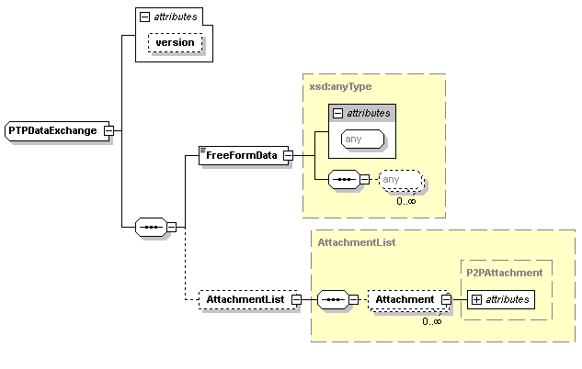

Gas_r36.xsd

- Change the version attribute of versioned type to r36:
- GasServiceOrderDetails complex type

Change from: xsd:attribute name="version" type="r34" use="optional" default="r34"/>
Change to: <xsd:attribute name="version" type="r36" use="optional" default="r36"/>

Impact Summary
This table identifies the files, transactions and versioned types that are potentially impacted as the result of these changes, where:
- Modified types - is a full list of types changed by this Change Request
- Derived types – is a list of any types that are derived from a modified type, and are therefore also modified by default
- Versioned types affected – is a list of all versioned types that will need to have the version attribute updated as a result of this Change Request
- Transactions potentially affected – is a list of all transactions that contain a modified type, either directly or via a type substitution
- Schema files affected – is a list of schema files that will be changed in some way as a result of this Change Request.

Modified types | Derived types | Versioned types affected | Transactions potentially affected | Schema files affected
 |  |  |  | aseXML_r34.xsd
 |  |  |  | Events_r34.xsd
ServiceOrderType  ServiceOrderSubType  ElectricityMeter  ElectricityServiceOrderDetails  ElectricityMeterRegisterDetail | ElectricityMeter  ElectricityMeters | ElectricityStandingData  ServiceOrderRequestData | NMIDiscoveryResponse  NMIStandingDataResponse  CATSChangeRequest  CATSNotification  CATSDataRequest  ServiceOrderRequest  ServiceOrderResponse  AmendMeterRouteDetails  AccountCreationNotification  MeterReadInputNotification  SpecialReadRequest  SpecialReadResponse  NMIStandingDataUpdateNotification  CATSBulkDataRequest  MeterReadingReferenceDataResponse  ReportResponse | Electricity_r36.xsd
ElectricityMasterStandingData |  | ElectricityStandingData | MeterDataVerifyRequest  MeterDataMissingNotification  NMIStandingDataResponse  NMIDiscoveryResponse  CATSChangeRequest  CATSNotification  CATSDataRequest  ReplicationNotification  ReportResponse | ElectricityMasterStandingData_r36.xsd
ServiceOrderRequest  ServiceOrderResponse |  |  | ServiceOrderRequest  ServiceOrderResponse  SpecialReadRequest  SpecialReadResponse | ServiceOrder_r36.xsd
CustomerDetail |  | GasServiceOrderDetails | ServiceOrderRequest  ServiceOrderResponse  CustomerDetailsNotification | CustomerDetails_r36.xsd
Table 2-3, Impact Summary

Developer Test

Test Platforms
Development of modified schema files has been completed and tested.

Test Cases
- Basic regression tests with only absolutely required changes from r35 level. Eg mandatory LifeSupport element in ServiceOrderRequest transactions.
- Full inclusion of optional and required when available element.
- ControlEquipment attached to meter and wire connected to Meter cases.
- Notified party for transaction Ack, Message Nack, Service order request and Service order response.

Proposal Assessment

Test
The ASWG ensures that all recommended parsers on relevant platforms can successfully validate the proposed schema.

Test Platforms
Supplied samples have been tested using the following parsers:
- MSXML 6.0 SP1
- Xerces 2.2.1
- Xerces 2.9.1
- XMLSpy 2014

Test Cases

Test Results
<All OK… or note issues>

Conformance Report
The ASWG completes the conformance report validating each proposed new schema file against the published aseXML guidelines.
Schema Filename | Impacted by Item # | Conformance Details
aseXML_r*.xsd | 1,2 | <Conforms… or note non-conformance>
Table 3-4, Change Proposal Conformance Details

Issue Register
This section describes any issues that have arisen and any modifications that are made to the original proposal during the Change Process

Status of Issues
Issue# | Item# | Description and Discussion | Status | Resolution
1
Table 4-5, Issues list

Resolution
The ASWG votes for endorsement of the options identified in section 2, and the voting results are forwarded to AEMO for approval. When 75% of those ASWG members who voted endorse a specific option, this represents an ASWG Recommendation for that option. AEMO will not reject an ASWG Recommendation without first consulting with the ASWG.

ASWG Endorsement
The results of the ASWG vote are as follows:
Date of Vote: ??/??/????

Option | # Votes | % Vote
Option 1 (section 2.1)
Option 2 (section 2.2)
Option # (section 2.#)
Abstained
Total Members Present
Table 5-6, ASWG Vote Results

Change Type can be one of - New - Enhancement, or - Bug Fix
Either ‘Open’ or ‘Closed’

