|  |  |  |
| --- | --- | --- |
| Trip of multiple 220 kv transmission lines at glenrowan on 25 april 2015 | | |
|  | | |
| AN AEMO POWER SYSTEM OPERATING INCIDENT REPORT FOR THE NATIONAL ELECTRICTY MARKET | | |
| Published: **September 2015** |  |  |

VERSION RELEASE HISTORY

|  |  |  |  |  |  |
| --- | --- | --- | --- | --- | --- |
| VERSION | DATE | BY | CHANGES | CHECKED BY | AUTHORISED BY |
| 1 | 3 August 2015 | M Ting | Final | J Lu | P Biddle |

INCIDENT CLASSIFICATIONS

|  |  |
| --- | --- |
|  |  |
| Time and date of incident | 0329 hrs Saturday 25 April 2015 |
| Region of incident | Victoria |
| Affected regions | Victoria |
| Event type | Protection and Control |
| Generation Impact | No generator was disconnected or limited as a result of this incident |
| Customer Load Impact | No customer load was disconnected as a result of this incident |
| Associated reports | Nil |

ABBREVIATIONS

|  |  |
| --- | --- |
| Abbreviation | Term |
| AEMO | Australian Energy Market Operator |
| CB | Circuit Breaker |
| kV | Kilovolt |
| MW | Megawatt |
| NER | National Electricity Rules |

Important Notice

#### Purpose

AEMO has prepared this document to provide information about this particular Power System Operating Incident.

#### Disclaimer

This document or the information in it may be subsequently updated or amended. This document does not constitute legal or business advice, and should not be relied on as a substitute for obtaining detailed advice about the National Electricity Law, the National Electricity Rules, or any other applicable laws, procedures or policies. AEMO has made every effort to ensure the quality of the information in this document but cannot guarantee its accuracy or completeness.

Accordingly, to the maximum extent permitted by law, AEMO and its officers, employees and consultants involved in the preparation of this document:

* make no representation or warranty, express or implied, as to the currency, accuracy, reliability or completeness of the information in this document; and
* are not liable (whether by reason of negligence or otherwise) for any statements or representations in this document, or any omissions from it, or for any use or reliance on the information in it.

Copyright 2014. Australian Energy Market Operator Limited. The material in this publication may be used in accordance with the copyright permissions on AEMO’s website.

# OVERVIEW

This report reviews a power system operating incident on 25 April 2015 at Glenrowan Terminal Station (GNTS) in Victoria. This incident involved the simultaneous trip of the following three 220 kV lines:

* Glenrowan to Shepparton No. 3 220 kV line (GNTS-SHTS 3 line).
* Dederang to Glenrowan No. 1 220 kV line (DDTS-GNTS 1 line).
* Dederang to Glenrowan No. 3 220 kV line (DDTS-GNTS 3 line).

No customer load was lost as a result of this incident.

The power system is operated such that it will remain in a satisfactory[1] operating state for the loss of single elements in the transmission network. Such events are defined as credible contingency[2] events. AEMO considers the occurrence of these events to be reasonably possible and will ensure contingency plans are in place to minimise the impact on the power system following a credible contingency event. A non-credible contingency event is a contingency event other than a credible contingency event.

AEMO is required to assess power system security over the course of this incident as the incident is classified as a non-credible contingency under the National Electricity Rules (NER)[3]. Specifically, AEMO is required to assess the adequacy of the provision and response of facilities and services and the appropriateness of actions taken to restore or maintain power system security[4].

AEMO concluded that:

1. The GNTS-SHTS 3 line tripped due to a fault on the line.
2. Both DDTS-GNTS 1 and 3 lines tripped due an incorrect current differential protection operation.
3. Power system security was maintained over the course of the incident.

This report is based on information provided by AusNet Services[5] and AEMO. National Electricity Market time (Australian Eastern Standard Time) is used in this report.

# the incident

On Saturday 25 April 2015, at 0329 hrs, the following incident occurred:

* The GNTS-SHTS 3 line tripped and auto reclosed at both GNTS and Shepparton Terminal Station (SHTS).
* The DDTS-GNTS 1 line tripped and auto reclosed at both Dederang (DDTS) and GNTS.
* The DDTS-GNTS 3 line tripped at both DDTS and GNTS, did not auto-reclose and remained out of service.

The DDTS-GNTS 3 line was returned to service approximately four hours later at 0741 hrs.

No load or generation was lost as a result of this incident. See Appendix A for a power system diagram illustrating the incident and Appendix B for a chronological log of the incident.

The reason for investigating this incident is that both DDTS-GNTS 1 and 3 lines tripped due to a fault on the GNTS-SHTS 3 line. Generally transmission lines should remain in service when there are faults on other transmission lines. The simultaneous trip of three lines is an unexpected event and is considered as a non-credible contingency.

# AUSNET Investigation

AusNet investigated this incident and found that:

1. The GNTS-SHTS 3 line tripped on a white phase to earth fault. Both X and Y[6] current differential protection relays at each end detected the fault, and tripped the GNTS-SHTS 3 line. The GNTS-SHTS 3 line auto reclosed and returned to service immediately. The protection for the GNTS-SHTS 3 line operated correctly and cleared the fault within mandated clearance times.
2. Both DDTS-GNTS 1 and 3 lines tripped due to the incorrect operation of one of the current differential protections at both DDTS and GNTS. This was caused by incorrect settings on communications equipment at DDTS. This resulted in a symmetry issue on the communications channels between GNTS and DDTS causing incorrect operation of the current differential protection. On 29 April 2015, AusNet corrected the communications equipment setting at DDTS.

The DDTS-GNTS 1 line successfully auto reclosed and returned to service immediately via the DDTS Line/SHTS Line 220 kV CB. The DDTS 1 line 220 kV No.1 bus CB stayed opened at GNTS because it is not normally enabled for auto-reclose. This 220 kV No.1 bus CB was manually closed 20 minutes after the incident.

The DDTS-GNTS 3 line stayed open at both ends as the auto-reclose failed to operate. At GNTS, the auto reclose was enabled on the DDTS 3 line 220 kV No. 1 bus CB. The reclose condition for this 220 kV bus CB is live bus dead line. The live bus condition was not fulfilled because the bus voltage is derived from either the DDTS 1 line or DDTS 3 line, both of which had tripped during this incident. As the auto-reclose sequence requires the line to be energised from GNTS end first the auto-reclose at DDTS end also did not eventuate.

AusNet patrolled the GNTS-SHTS 3 line on 28 April 2015 and did not find any cause for this incident.

# power system security

This section assesses how power system security was managed over the course of the incident[7].

1. AEMO’s response on 25 April 2015

On 25 April 2015 at 0340 hrs, approximately 11 minutes after the incident occurred AEMO invoked constraint set V-DDGN[8]. This ensured that the power system was returned to or maintained in a secure operating state whist DDTS-GNTS 3 line remained out of service. AEMO is required to return the power system to a secure state within thirty minutes following a contingency event[9].

At 0354 hours, AEMO issued Market Notice 48773 to notify the market of the outage of the DDTS-GNTS 3 line and the constraint set had been invoked. At 0359 hours, AEMO issued Market Notice 48774 to notify the market of the non-credible contingency event.

At 0741 hours, AusNet returned the DDTS-GNTS 3 line to service. Subsequently at 0800 hours, AEMO revoked the constraint set V-DDGN and issued Market Notice 48780 to notify the market.

AEMO then assessed whether or not to reclassify the event as a credible contingency[10]. At the time the DDTS-GNTS 3 line was returned to service, AusNet provided following information:

* All three phases tripped for all three lines.
* While the cause of the incident could not be definitively identified, AusNet thought it was caused by lightning.

Based on this information AEMO did not reclassify this incident as a credible contingency. This is because at the time when the DDTS-GNTS 3 line was returned to service lightning was not observed in the vicinity of the DDTS-GNTS or GNTS–SHTS lines and AEMO considered the incident as unlikely to reoccur.

1. AEMO’s follow up response

On 27 April 2015, two days after the incident, AusNet informed AEMO following:

* The initial fault was located on the GNTS-SHTS 3 line.
* Both DDTS-GNTS 1 and 3 lines tripped due to incorrect operation of one of the current differential protections. The protection issues were still under investigation.

Therefore, on the same day at 1413 hrs, AEMO reclassified the incident as a credible contingency and issued Market Notice 48791 to notify the market of the reclassification. AEMO subsequently invoked constraint set V-DDGN_N-2[11] at 1415 hrs to manage power system security.

On 29 April 2015, AusNet corrected the communications equipment setting at DDTS. AEMO revoked constraint set V-DDGN_N-2 and cancelled the reclassification. Market Notice 48811 at was issued at 1521 hrs to notify the market.

For this incident the power system remained in a secure operating over the course of the incident.

AEMO correctly reclassified the incident based on advice from AusNet and issued appropriate notifications to the market.

# conclusions

AEMO concluded that:

1. The GNTS-SHTS 3 line tripped and auto-reclosed due to a white phase to earth fault. The protection on this line operated correctly.
2. Both DDTS-GNTS 1 and 3 lines tripped due to an incorrect communications card setting that caused incorrect current differential protection operation of one of the two protections. The communications card setting has since been rectified.
3. The provision and response of facilities and services were appropriate and power system security was maintained over the course of the incident.
4. There are no outstanding issues to resolve as a result of this incident.
5. – power system diagram

The power system immediately after the incident. Both GNTS-SHTS 3 and DDTS-GNTS 1 lines auto-reclosed successfully and returned to service.

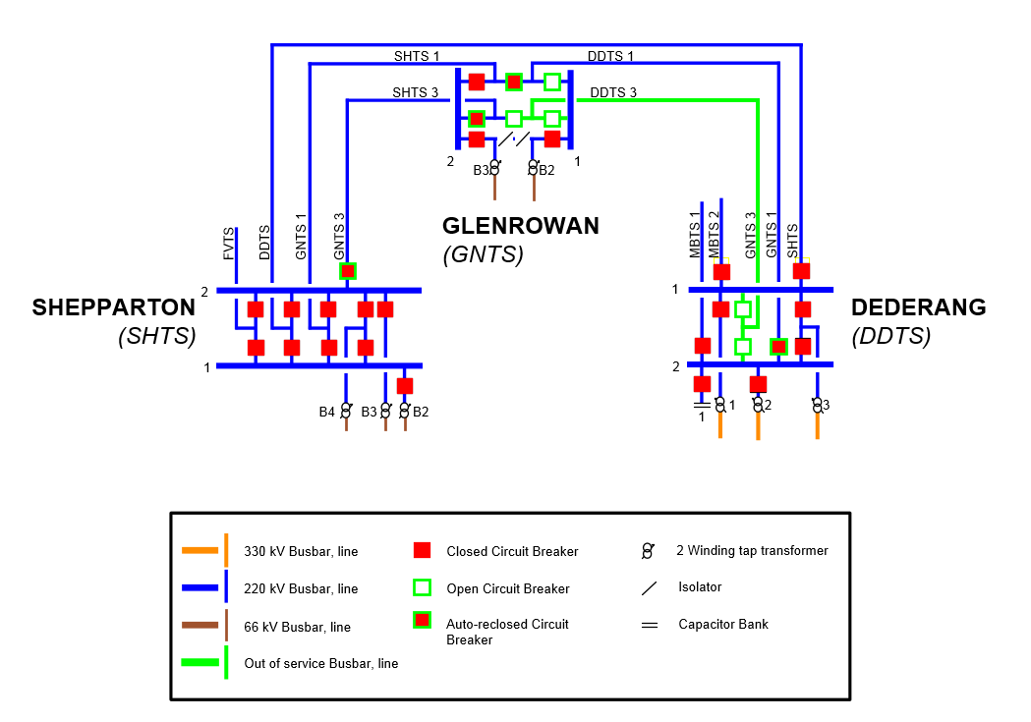

1. – incident event log
2. Incident Log

|  |  |
| --- | --- |
| Time and Date | Event |
| 0329 hrs 25 Apr 2015 | The following lines tripped:   * GNTS-SHTS 3 line opened at both ends * DDTS-GNTS 1 line opened at both ends * DDTS-GNTS 3 line opened at both ends |
| 0329 hrs 25 Apr 2015 | Both GNTS-SHTS 3 line and DDTS-GNTS 1 line auto reclosed successfully. |
| 0340 hrs 25 Apr 2015 | Constraint set V-DDGN invoked. |
| 0350 hrs 25 Apr 2015 | DDTS-GNTS 1 line 220 kV bus CB manually reclosed at GNTS end. |
| 0354 hrs 25 Apr 2015 | Market Notice 48773 issued. Notification of constraint set V-DDGN invoked. |
| 0359 hrs 25 Apr 2015 | Market Notice 48774 issued. Notification of the non-credible contingency event. |
| 0741 hrs 25 Apr 2015 | DDTS-GNTS 3 line manually reclosed at both ends. |
| 0800 hrs 25 Apr 2015 | Constraint set V-DDGN revoked. |
| 0817 hrs 25 Apr 2015 | Market Notice 48780 issued. Notification of constraint set V-DDGN revoked. |
| 1413 hrs 27 Apr 2015 | Market Notice 48791 issued. Notification of the reclassification of the non-credible contingency event as a credible contingency event, and constraint set V-DDGN_N-2 invoked. |
| 1415 hrs 27 Aug 2015 | Constraint set V-DDGN_N-2 invoked. |
| 1505 hrs 29 Aug 2015 | Constraint set V-DDGN_N-2 revoked. |
| 1521 hrs 29 Aug 2015 | Market Notice 48811 issued. Notification of the cancellation of the reclassification, and constraint set V-DDGN_N-2 revoked. |

1. Refer to NER 4.2.2
2. Refer to NER 4.2.3
3. Clause 4.8.15(a)(1)(i) and AEMC Reliability Panel Guidelines for Identifying Reviewable Operating Incidents.
4. NER Clause 4.8.15 (b).
5. AusNet Services is a Transmission Network Service Provider in Victoria. Information provided by AusNet Services has been provided on a without prejudice basis and nothing in this report is intended to constitute, or may be taken by any person as constituting, an admission of fault, liability, wrongdoing, negligence, bad faith or the like on behalf of AusNet Services (or its respective associated companies, businesses, partners, directors, officers or employees).
6. Protection schemes on transmission network are usually replicated (i.e. two schemes are provided for one network element). Generally where two schemes are used they are notionally known as X and Y.
7. AEMO is responsible for power system security in the NEM and is required to operate the power system in a secure operating state (NER Clause 4.2.4 (a)). AEMO must thereby ensure that the power system is maintained in, or returned to, a secure operating state following a contingency event.
8. Out = Dederang to Glenrowan No.1 or No. 3 220 kV line
9. AEMO is required to return the power system to a secure state within thirty minutes following a contingency event - NER Clause 4.2.6 (b).
10. AEMO is required to assess whether or not to reclassify a non-credible contingency event as a credible contingency - NER Clause 4.2.3A (c)) - and to report how re-classification criteria were applied - NER Clause 4.8.15 (ca). AEMO has to determine if the condition that caused the non-credible contingency event has been resolved.
11. Out = Dederang to Glenrowan No.1 and No. 3 220 kV lines