Reserve Level Declaration Guidelines

PREPARED BY: | AEMO Operations [Group]
DOCUMENT REF: | XX-XXXX
VERSION: | [Draft 0.1]
EFFECTIVE DATE: | [ ]
STATUS: | DRAFT
Approved for distribution and use by:
APPROVED BY: | DAMIEN SANFORD
TITLE: | Executive General Manager Operations
DATE: | / / 20

Version Release History
Version | Effective Date | Summary of Changes
0.1 | NA | Draft issued with AEMC Draft Determination: National Electricity Amendment (Declaration of lack of reserve conditions) Rule 2017
1.0 | [ ] | First issue for National Electricity Amendment (Declaration of lack of reserve conditions) Rule 2017

Contents
1. Introduction 4
1.1. Purpose and scope 4
1.2. Definitions and interpretation 4
1.3. Related documents 5
2. Assessment and publication 5
3. forecast UNCERTAINTY MEASURE 6
3.1. Forecast regional excess supply (RXS) 6
3.2. Determining RXS error distribution 6
3.3. Forecast uncertainty measure (FUM) calculation 6
4. credible contingency sizes 6
5. Description of Reserve Levels 7
5.1. LOR3 7
5.2. LOR2 7
5.3. LOR1 7
Appendix A. Forecast Uncertainty Error Methodology 8
A.1 Sources of error 8
A.2 Bayesian Belief network 9
Appendix B. lor methodology 12

Introduction

Purpose and scope
These are the reserve level declaration guidelines made under clause [4.8.4A] of the National Electriciy Rules (Guidelines).
These Guidelines have effect only for the purpose of declaring lack of reserve (LOR) conditions under clause [4.8.4] of the National Electricity Rules (NER). They describe the considerations and methodology AEMO applies in deciding to declare an LOR condition, and the levels of LOR conditions that may be declared.
An LOR declaration alerts Registered Participants to a probability of capacity reserves being insufficient to avoid load shedding (other than interruptible load) given reasonably foreseeable conditions and events.
The NER and the National Electricity Law prevail over these Guidelines to the extent of any inconsistency.

Definitions and interpretation

Glossary
Terms defined in the NER or the National Electricity Law have the same meanings in these Guidelines unless otherwise specified in this clause. Those terms are intended to be identified in these Guidelines by italicising them, but failure to italicise a defined term does not affect its meaning.
The words, phrases and abbreviations in the table below have the meanings set out opposite them when used in these Guidelines.
Term | Definition
AEMO | Australian Energy Market Operator Limited
AWEFS | Australian Wind Energy Forecasting System
ASEFS | Australian Solar Energy Forecasting System
BBN | Bayesian Belief Network
BOM | Bureau of Meteorology
FUM | Forecast uncertainty measure
LCR | Largest credible risk – see clause 4
LCR2 | Two largest credible risks – see clause 4
LOR | Lack of reserve (may be followed by a number corresponding with a reserve level defined in these Guidelines)
LOR assessment horizon | The period of time described in clause 2(a)
LOR Load Shedding | The reduction or disconnection or reduction of load (other than interruptible load).
LOR1 threshold | The level of capacity reserves below which AEMO may declare an LOR1 condition – see clause 2(d)
LOR2 threshold | The level of capacity reserves below which AEMO may declare an LOR2 condition – see clause 2(c).
MW | Megawatts
MWh | Megawatt hours
NER | National Electricity Rules
Operational Demand | A quantity (in MW) determined by AEMO representing the instantaneous demand of load (other than scheduled load) to be supplied by sent out generation of scheduled generating units, semi-scheduled generating units, and significant non-scheduled generating units. For further information about demand definitions see “AEMO Operational Demand Definition – Summary Document”
RXS | Regional excess supply
RXS error | The expected difference between forecast RXS and actual RXS (see clause 3.2)
STPASA | Short-term PASA

Interpretation
The following principles of interpretation apply to these Guidelines unless otherwise expressly indicated:
      - These Guidelines are subject to the principles of interpretation set out in Schedule 2 of the National Electricity Law.
      - References to time are references to Australian Eastern Standard Time.
      - The following mathematical notations used in formulae and equations have these meanings:
        - MAX ( ) means the maximum (or highest) of two or more values within the brackets,
        - '{ }', '( )' and '[ ]' indicates that all calculations between a pair of brackets are to be performed separately from expressions outside the brackets. Different forms of brackets are used only for ease of matching the opening bracket with the corresponding closing bracket.

Related documents
Title | Location
Reliability Standard Implementation Guidelines | www.aemo.com.au
Short Term PASA Process Description | www.aemo.com.au
Intervention, Direction and Clause 4.8.9 Instructions SO_OP3707 | www.aemo.com.au
Procedure for the Dispatch and Activation of Reserve Contracts SO_OP3717 | www.aemo.com.au
AEMO Operational Demand Definition – Summary Document | www.aemo.com.au

Assessment and publication

  - AEMO assesses the probability of a shortfall in available capacity reserves leading to LOR Load Shedding in each region on a continuous basis, from the current time to the end of the period covered by the most recently published short term PASA. This is the LOR assessment horizon.
  - AEMO publishes, for each 30 minute period commencing on the hour and half-hour within the LOR assessment horizon, and for each region:
    - the expected capacity reserves (in MW);
    - the LOR2 threshold (in MW) – see paragraph (c); and
    - the LOR1 threshold (in MW) – see paragraph (d).
  - The LOR2 threshold within the LOR assessment horizon is MAX (LCR, FUM).
  - The LOR1 threshold within the LOR assessment horizon is MAX (LCR, FUM) + LCR2- LCR.

forecast UNCERTAINTY MEASURE

See also Appendix A for more detail.

Forecast regional excess supply (RXS)

  - The following forecasts and measurements in each region for the LOR assessment horizon will be assessed in determining the value of RXS:
    - available capacity of scheduled generating units (A);
    - unconstrained intermittent generation forecast (B); and
    - Operational Demand (C).
  - Forecast RXS for any time in the LOR assessment horizon is determined by the formula A + B – C.

Determining RXS error distribution

  - RXS Error = Forecast RXS – Actual RXS for a particular forecast and a point in time.
  - AEMO collects, stores and updates historical statistical data on RXS error, in different power system, ambient weather and other relevant conditions.
  - At the time of assessment, AEMO applies the historical data and the conditions expected for the relevant period in the LOR assessment horizon, as illustrated in Appendix A, to determine a distribution of error (RXS error) across all forecasts within the first [48] hours of the LOR assessment horizon. The input states that will be taken into account in developing the distribution will be:
    - forecast lead time
    - forecast regional reference node temperature;
    - current demand forecast error for forecast lead times below 24 hours; and
    - unconstrained intermittent generation forecast.

Forecast uncertainty measure (FUM) calculation

  - The FUM for a region, point in time and set of expected conditions, is the number of MW representing the quantity of RXS for which AEMO determines a [97%] confidence level of the RXS error not exceeding this value.
  - FUM will be determined using the RXS error for the first 48 hours of the LOR assessment horizon. The value of FUM at the end of that 48 hour period will be carried forward for the remainder of the LOR assessment horizon.

credible contingency sizes

  - AEMO determines the size of the two largest relevant credible contingency events that could affect the available supply of electricity for each region from time to time. The relevant credible contingency events will be published on the AEMO website alongside this guideline.
  - AEMO then determines the reduction in capacity reserves expected to result in that region from the occurrence of:
    - the single largest of those relevant credible contingency events (LCR) (in MW); and
    - both of the two largest credible contingency events, assuming they occur consecutively with sufficient time to return the power system to a secure operating state prior to the second event (LCR2) (in MW).

Description of Reserve Levels

AEMO will declare LOR conditions when it determines there is a non-remote probability of load shedding (other than interruptible load) due to a shortfall of available capacity reserves at a given time in the LOR assessment horizon, by reference to the criteria described in this clause for levels LOR3, LOR2 and LOR1. This is shown in the diagram in Appendix B.

LOR3

LOR3 will be declared for a region(s):
  - when LOR Load Shedding is occurring as a result of a shortfall of available capacity reserves (actual LOR3); or
  - for a period within the LOR assessment horizon when the forecast of available capacity reserves in the short term PASA or pre-dispatch schedule is at or below zero (forecast LOR3).

LOR2

LOR2 will be declared for a region(s):
  - when the occurrence of the largest relevant credible contingency event would result in LOR Load Shedding as a result of a shortfall of available capacity reserves (actual LOR2); or
  - for a period within the LOR assessment horizon when the forecast of available capacity reserves in the short term PASA or pre-dispatch schedule is less than LCR1 (forecast LOR2); or
  - for a period within the LOR assessment horizon when the forecast of available capacity reserves in the short term PASA or pre-dispatch schedule is less than FUM for the relevant period and region (forecast LOR2).

LOR1

LOR 1 will be declared for a region(s):
  - when the consecutive occurrence of both the largest and the second largest relevant credible contingency events (as described in clause 4(b)(b)(ii)) would result in LOR Load Shedding occurring as a result of a shortfall of available capacity reserves (actual LOR1); or
  - for a period within the LOR assessment horizon when the forecast of available capacity reserves in the short term PASA or pre-dispatch schedule is less than MAX (LCR,FUM) + (LCR2-LCR) (forecast LOR1).

- Forecast Uncertainty Error Methodology
This section describes how the historical forecasting data was analysed under different prevailing conditions in order to estimate the combined forecasting error.
- Sources of error
As described in clause 3.1, RXS error is determined using forecasts and measurements for:
- available capacity of scheduled generating units (A);
- unconstrained intermittent generation forecast (B); and
- Operational Demand (C).
    - Scheduled Generation
Every Scheduled Generator is required to submit an estimate of available capacity of each scheduled generating unit for every trading interval for the next 8 days. This provides AEMO with an estimate of how much generation is available for dispatch and may be updated at any time up to the point of dispatch. This variation is a significant source of forecasting error.
    - Semi/Non Scheduled Intermittent Generation
AEMO produces a generation forecast for every semi-scheduled generating unit and large intermittent non-scheduled generating units through its AWEFS and ASEFS forecasting systems. These forecasts are continuously updated and also create a significant source of forecasting error.
In some situations these generating units may be subject to constraints. This is a rare situation, and in trading intervals where this occurred, the relevant generating units were simply removed from the RXS calculation.
    - Operational Demand
AEMO currently produces Operational Demand forecasts at a regional level. These forecasts are continuously updated and also create a significant source of forecasting error.
    - Preparation of data
  - For every 30 minute trading interval since 2011 AEMO calculated forecast RXS for the next 384 trading intervals (8 days Ahead)
  - Each 30 minute forecast was assessed against the actuals for each of the next 96 trading intervals. For example a forecast run at say 01-01-2017 01:00 would have forecasts for each 30 minute interval from 01-01-2017 01:30 to 03-01-2017 01:00 and an RXS error created for each of these.
  - The known prevailing conditions that were present just prior to the forecast run were included to develop an understanding of how these conditions affect the forecasting error. The prevailing conditions that were known and assessed at the time of the forecast run were the following:
    - Current Temperature (BOM Airport Temperature by region)
    - Forecast Temperature (BOM Airport Temperature by region)
    - Prior Trading Interval Forecasting Error (Semi/Non Scheduled Generation & Operational Load Demand)
    - AWEFS Forecast
    - Regional reference price ($/MWh)
    - Time of Day (Day Time / Night Time Forecast).
  - As noted in A.2.1, not all of the above conditions were found to be significant to the RXS error distribution. These were discarded in order to simplify the calculation and enable the distributions to be built off a greater input sample size.
  - This data was then used to train a Bayesian Belief Network to produce a RXS error distribution for each of the next 96 trading intervals. This is dynamic: the error distributions will update based on the current prevailing conditions when the forecast is produced.
  - The output of the BBN is a measure of the RXS error in MW for each of the next 96 trading intervals. As we are dealing with a forecasting error distribution the “At Risk” MW (FUM) is associated with a confidence level. For example a 6 hour ahead forecast that was run at 22:00 for 04:00 (overnight forecast) would have less uncertainty associated with the error then a forecast run at 10:00 for 16:00 (daily peak forecast). The BBN outputs a MW value for each of the forecasts that is associated with a fixed confidence level. So for example in the 22:00 forecast run a typical FUM value for 6 hours ahead might be 200MW whereas for the 10:00 forecast run a typical FUM value for 6 hours ahead would be 300MW.
  - To determine the confidence level multiple values were analysed to determine the impact that each level had on raising additional alerts. The level that was chosen had to adhere to the following conditions:
    - It did not raise an unreasonable amount of additional alerts.
    - It is consistent across the regions.
    - It is consistent throughout the 96 forecast trading intervals.
  - The final step was to subtract the FUM MW from systems estimate of surplus reserves and raise an LOR event if this value was less the zero. The number of these LOR events were compared to the number of events that had been identified by AEMO under the present rules to ensure the increase was reasonable.
- Bayesian Belief network
This section provides background on a Bayesian Belief Network and how the prevailing conditions were incorporated.
A Bayesian Belief network, is a probabilistic graphical model that represents a set of random variables and their conditional independencies via a directed acyclic graph (DAG). For example, a Bayesian network could represent the probabilistic relationships between diseases and symptoms. Given symptoms, the network can be used to compute the probabilities of the presence of various diseases. In AEMO’s case the network is setup to operate such that, given prevailing conditions the network is used to compute the expected probabilities associated with the forecasting error. The network is trained on all of the historical forecasts and the associated prevailing conditions at the time of the forecast run.
Figure 1 below provides an example of a Short Term (Less than 6 hours) BBN network in the South Australian region. The blue nodes are the input nodes which represent the prevailing conditions that existed just prior to the forecast run and the green nodes represent the forecasting error for each of the next 30 minute trading intervals. The black bars represent the probability associated with each of the corresponding bins. For example, below circled in red is the BOM temperature recorded at the Adelaide airport. It shows that 15.5% of the time the temperature recordings have been between 0 and 12 degrees.

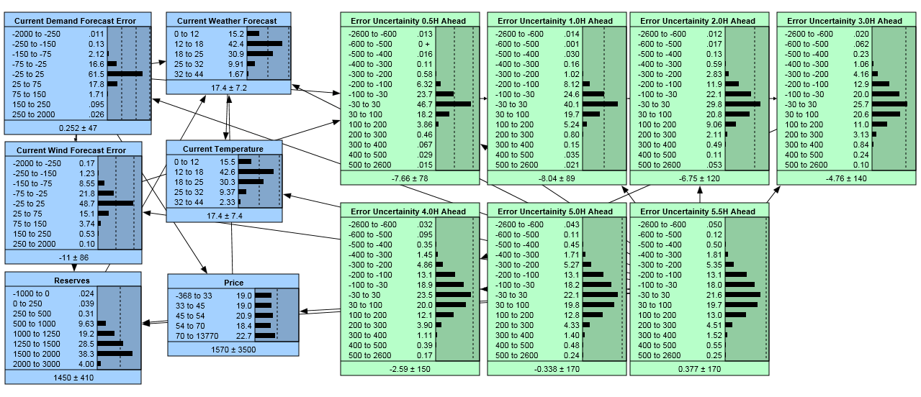
Figure 1: Bayesian Belief Network

    - Sensitivity Analysis

Once a BBN network has been trained it is possible to statistically assess the impact that each of the prevailing conditions (input nodes) has on the forecasting errors. Using just the link structure of the net, you can determine which nodes are completely independent of other nodes. However, dependence is a matter of degree and once the net has been trained it can be assessed how changes in the prevailing conditions change the probabilities or uncertainties in our forecasting error nodes (output nodes). From this analysis it was determined that the most significant prevailing conditions (the conditions that cause the largest change in forecasting uncertainty) are the following:
  - Temperature Forecast
  - Wind Forecast
  - Last Operational Demand Error (the error of the demand forecast from the previous 30 minute trading interval).
Additionally prevailing conditions that were assessed and determined to not cause a significant impact include:

  - Price
  - Last Wind Forecasting Error (i.e. the error from the wind forecast from the previous 30 minute trading interval)
  - Current actual RXS.
Therefore the BBN network includes Temperature Forecast, Wind Forecast and Last Operational Demand Error as the input data for the BBN models.
    - Selection of Confidence Level
The final step is selecting the MW values associated with the confidence level. Figure 2 found below is the forecasting error associated with the 5 Hour Ahead Forecasts. What this demonstrates is the combined forecasting error from all three forecasting systems 5 hours after the forecast was run. The black bars are the probabilities associated with each of the bin ranges and the bins are in MW. For example 19.8% percent of the time AEMO produces a forecasting error of between 30-100MW
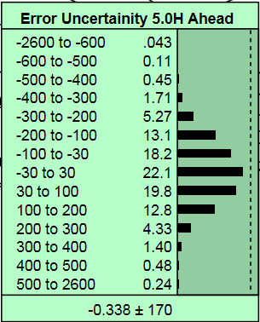
Figure 2: 5 Hour Ahead Forecasting Error

In order to determine the associated MW value for the confidence level all the probabilities are accumulated until they exceed the confidence interval and the associated MW value in that bin becomes FUM. It should be noted that the BBN outcomes shown in the figures are derived from a concept demonstration model. The BBN used by AEMO in production has bin values of 20MW size. Thus the FUM is calculated to 20MW intervals.
.

- lor methodology

Capacity Reserves (MW)
Forecast Time
LCR
LCR2
FUM
1st
contingency
2nd
contingency
LOR2
LOR1
LOR3
Now
2nd contingency
48 hours

