Schema Release
AseXML Schema Working Group
Release r43

February 2023

Draft Release Date: 04 January 2023
Final Release Date: 15 February 2023

Version Control
Version | Release date | Changes
0.1 | 09 February 2023 | Creation
0.2 | 10 February 2023 | Finalised after ASWG approval

Contents
1. Introduction 4
2. Change Requests 4
2.2 Reason for Change 5
2.3 Supplied Documents 5
3. Impact Summary 5
4. File Change Summary 7
4.1 aseXML 7
4.2 Changes 7
5. Schema Manifest 31
6. Schema Test 32
6.1 Test 32
7. ASWG Endorsement 34
8. AEMO Approval 34

Tables
Table 1 Proposed Changes 5
Table 2 Impacted items 12
Table 3 Change Log 15
Table 4 Schema Files 26

Figures
No table of contents entries found.

Introduction
Version r43 of the aseXML schema has been developed from r42. This schema release is presented to aseXML Subscribers and Industry Participants for review and to AEMO for approval, in accordance with the ASWG Terms of Reference.

Change Requests
The proposed changes are listed in the following table.
Item# | Change Description | Change Type
1 | MSDR changes to support C1 Report:  - Define following new complex elements in schema for representation of code(s) tables:  - MSATSCodeGroupsRow  - MSATSCodesDatedRow  - MSATSCodeComboRow  - MSATSCodesRow  - Increase length of MSATSCodeValue from 15 to 100  - Update existing version attribute for MSATSCodeValuesRow from r19 to r43. | New
2 | CDR Phase 2:  - Define a new element ‘LastConsumerChangeDate’ of type date.  - Add this element reference to existing ElectricityNMIMasterGroup and ElectricityMasterStandingData elements | New
3 | SAPS:  - Define new complex element ‘NodeHierarchyRow’ in schema for representation of node hierarchy table  - Define new complex element ‘MDMTSettlementCaseDetailsReportParameters’ for the new Regulated SAPS Generator Reconciliation report. The purpose of the RM51 – Regulated SAPS Generator Reconciliation report is to provide MSRP (FRMP) participants with the energy values used to calculate the Generator allocation within a settlement run.  - Define new element as RoleCategory for ParticipantRolesRow | New
4 | B2B Changes  - Add SharedFuseNotification transaction. | New
- Proposed Changes

Change Description
MSDR :
There is currently no C1 replication report for the codes tables (Codes/Codes Dated/Code Combos etc), which is now extensively used for the new enumerations in MSDR project. These tables will be added to schema for being replicated though C1 report.
Schema changes required for MSDR are as follows:
- Define following new complex elements in schema for representation of code(s) tables:
  - MSATSCodeGroupsRow
  - MSATSCodesDatedRow
  - MSATSCodeComboRow
  - MSATSCodesRow
- Increase length of MSATSCodeValue from 15 to 100
- Update version attribute for MSATSCodeValuesRow from r19 to r43.

CDR:
Addition of new field to provide more complete and accurate Standing Data to support CDR.
Schema changes required for CDR are as follows:
- Addition of new field ‘LastConsumerChangeDate’ to existing ElectricityNMIMasterGroup and ElectricityMasterStandingData.
- Update version attribute of following existing elements from r42 to r43:
  - ElectricityNMIMasterRow
  - ElectricityNMIMasterRowBDT
  - ElectricityCATSChangeRequestNMIMasterRow and
  - ElectricityStandingData

SAPS:

Schema changes required for SAPS are as follows:
- Define new complex element ‘NodeHierarchyRow‘ in schema for representation of node hierarchy table
- Define new complex element ‘MDMTSettlementCaseDetailsReportParameters’ for the new Regulated SAPS Generator Reconciliation report
- Define new element as RoleCategory for ParticipantRolesRow

B2B :
As part of B2B Consultation v3.8, One Way Notification Process will include a new transaction ‘SharedFuseNotification’ to indicate the current status of a shared fuse arrangement. The Change is focused on delivering uniformity and process efficiencies in B2B communications for shared fuse arrangements to support the Metering Coordinator Planned Interruption (MCPI) rule change, which introduced new obligations for Retailers and MCs to provide information to the DNSP regarding the shared fuse status at a site.
It should be noted that while the B2B Procedures v3.8 describes a set of enumerated values for the shared fuse arrangement describing the state of a NMI, as follows:
• ‘N’ – Not Shared Fuse
• ‘I’ – Shared Fuse but can be isolated independently
• ‘Y’ – Shared Fuse
The Final Determination specifies that “AEMO will create a new aseXML OWN transaction in the schema, to carry this information with any enumerations managed outside the schema”. This Change Request to the ASWG notes that while there are precedents where B2B enumerations are defined in the non-versioned Enumerations.xsd, as the allowed enumerations of the B2M SharedIsolationPointFlag are not managed here, and the Shared Market Protocol eHub does not validate the content of B2B transactions; it is proposed that the outcome of the Final Determination be upheld.

Schema changes required for B2B are as follows:
- Define new transaction SharedFuseNotification with following elements:
  - NMI, NMIChecksum
  - IdentifiedDate
  - SharedIsolationPointFlag

Reason for Change
These changes are made in the interests of improving efficiency, reducing costs and ensuring compliance with the National Electricity Objective. These changes were consulted and agreed upon in various forums.
The new fields added in schema provided an opportunity to ensure MSATS Standing Data reflects the needs of the market by standardising the data and ensuring that data are complete, accurate and useful.
The MC, MP or Retailer will generate the new B2B transaction ‘SharedFuseNotification’ (either via participant market systems or the MSATS browser) with an appropriate code to indicate the status of the Shared Fuse indicator for each NMI.
The purpose of the RM51 – Regulated SAPS Generator Reconciliation report is to provide MSRP (FRMP) participants with the energy values used to calculate the Generator allocation within a settlement run.

Supplied Documents
Not applicable.

Business process document
Please find relevant links to the associated Procedures and Consultations below:

Function | Initiative | Procedure | Consultation | Schema Requirement
B2M | CDR Phase 2 | Standing Data for MSATS v5.4  MSATS Procedures - CATS v5.4  MSATS Procedures - WIGS v5.4 | Final report and determination – Part 2 Consumer Data Rights | New aseXML schema element to support the CATS NMI Standing Data column ‘Last Consumer Change Date’:  - Addition of a new Change request that would include the column ‘Last Consumer Change Date’ to be maintained against the CATS NMI Data table within MSATS.  - This field would be maintained by retailers when the consumer for a NMI changes, e.g. move-ins and used by AEMO to verify meter data requests for CDR.  - The field can also be updated ad hoc where the retailer has verified the consumer's start date.
B2B | B2Bv3.8 | B2B Procedure One Way Notification Process v3.8 | Final report and determination - B2B Procedures v3.8 | Creating a new OWN Shared Fuse One Way Notification transaction type, supporting enumerated values.

Other
The r43 schema is scheduled for the MSATS 49.0 release. The latest version of the MSATS 49.0 technical specification that covers these changes can be found here at https://www.aemo.com.au/energy-systems/market-it-systems/it-change-and-release-management.

Impact Summary
This table identifies the files, transactions and versioned types that are changed in this schema, where:

- Modified types - is a full list of types changed in this schema
- Derived types – is a list of any types that are derived from a modified type, and are therefore also modified by default
- Versioned types affected – is a list of all versioned types that will need to have the version attribute updated to use this schema
- Transactions potentially affected – is a list of all transactions that contain a modified type, either directly or via a type substitution
- Schema files affected – is a list of schema files that have been changed in some way for this schema.
- Impacted items

Modified types | Derived types | Versioned types affected | Transactions potentially affected | Schema files affected
 |  |  |  | aseXML_r43.xsd
R43 |  |  |  | Events_r43.xsd
ParticipantRolesRow |  |  | ReplicationNotification | CATSTableReplication_r43.xsd
ElectricityNMIMasterGroup  ElectricityMasterStandingData | ElectricityCATSChangeRequestNMIMasterRow  ElectricityNMIMasterRowBDT  ElectricityNMIMasterRow | ElectricityStandingData | NMIStandingDataResponse  ReportResponse  CATSChangeRequest | ElectricityMasterStandingData_r43.xsd
MDMTSettlementCaseDetailsReportParameters |  |  |  | MDMTReports_r43.xsd
SharedFuseNotification |  | SharedFuseNotification | SharedFuseNotification | OneWayNotification_r43.xsd

File Change Summary
The following file changes are implemented to create the r43 schema version

aseXML
Changed aseXML namespace to urn:aseXML:r43

Changes
The following changes have been implemented in this draft:
Chg # | Item # | Description of change | Filename
1 |  | - Replace version of schema from r42 to r43  - Rename file to r43 version. | aseXML_r43.xsd
2 |  | - Registration of r43 release  - Rename file to r43 version. | Events_r43.xsd
3 | 1,2,3 | - Define following new complex elements in schema for representation of code(s) tables:  - MSATSCodeGroupsRow  - MSATSCodesDatedRow  - MSATSCodeComboRow  - MSATSCodesRow  - NodeHierarchyRow  - Increase length of MSATSCodeValue from 15 to 100  - Update version attribute for MSATSCodeValuesRow from r19 to r43.  - Define new element as RoleCategory for ParticipantRolesRow  - Update version attribute of following existing elements from r42 to r43:  - ElectricityNMIMasterRow  - ElectricityNMIMasterRowBDT  - ElectricityCATSChangeRequestNMIMasterRow  - Rename file to r43 version | CATSTableReplication_r43.xsd
4 | 3 | - Add new element ‘RoleCategory’  - Rename file to r43 version | Common_r43.xsd
5 | 2 | - Update version attribute of following existing elements from r42 to r43:  - ElectricityStandingData  - Rename file to r43 version | Electricity_r43.xsd
6 | 2 | - Add new element ‘LastConsumerChangeDate’ to ElectricityNMIMasterGroup and ElectricityMasterStandingData  - Rename file to r43 version. | ElectricityMasterStandingData_r43.xsd
 | 3 | - Define new complex element ‘MDMTSettlementCaseDetailsReportParameters’ for the new Regulated SAPS Generator Reconciliation report | MDMTReports_r43
7 | 4 | - Define new complex type ‘SharedFuseNotification’ transaction.  - Rename file to r43 version. | OneWayNotification_r43.xsd
8 | 4 | - Add new B2B transaction ‘SharedFuseNotification’ to existing complex type ‘Transaction’  - Rename file to r43 version | Transactions_r43.xsd
- Change Log

Schema change description

aseXml_r43.xsd
- New file to replace aseXML_r42.xsd and include the r423 file versions listed below.

<xsd:schema xmlns="urn:aseXML:r43" xmlns:xsd="http://www.w3.org/2001/XMLSchema" xmlns:xsi="http://www.w3.org/2001/XMLSchema-instance" targetNamespace="urn:aseXML:r43" version="r43" xsi:schemaLocation="urn:aseXML:r43 aseXML_r43.xsd">

<xsd:include schemaLocation="CATSTableReplication_r43.xsd">
<xsd:include schemaLocation="Common_r43.xsd">
<xsd:include schemaLocation="Electricity_r43.xsd">
<xsd:include schemaLocation="ElectricityMasterStandingData_r43.xsd"/>
<xsd:include schemaLocation="Events_r43.xsd">
<xsd:include schemaLocation="MDMTReports_r43.xsd">
<xsd:include schemaLocation="OneWayNotification_r43.xsd">
<xsd:include schemaLocation="Transactions_r43.xsd">

CATSTableReplication_r43.xsd
- Added following new complex elements :
  - MSATSCodeGroupsRow
  - MSATSCodesDatedRow
  - MSATSCodeComboRow
  - MSATSCodesRow
  - NodeHierarchyRow
- Added following simple type elements:
  - MSATSCodeGroup
  - MSATSCodeTableType
  - MSATSCode
- Increase data length of existing element ‘MSATSCodeValue’ from 15 to 100 characters
- Added new element RoleCategory in existing ParticipantRolesRow complex type
- Updated version attribute of following existing elements from r42 to 43:
  - ElectricityNMIMasterRow
  - ElectricityNMIMasterRowBDT
  - ElectricityCATSChangeRequestNMIMasterRow
- Rename file to r43 version.

<!-- MSATS_CODE_GROUPS Row -->
<xsd:complexType name="MSATSCodeGroupsRow">
<xsd:annotation>
<xsd:documentation>
Purpose - Row of the MSATSCodeGroups table
MSATS Data Model Table - MSATS_CODE_GROUPS
Replication Table Name - MSATSCodeGroups
</xsd:documentation>
</xsd:annotation>
<xsd:complexContent>
<xsd:extension base="ReplicationBaseRow">
<xsd:sequence>
<xsd:element name="CodeGroup" type="MSATSCodeGroup"/>
<xsd:element name="Description" type="MSATSCodeValueDescription"/>
<xsd:element name="CodeTable" type="MSATSCodeTableType"/>
<xsd:element name="CodeGroupLastChanged" type="xsd:dateTime" minOccurs="0"/>
</xsd:sequence>
<xsd:attribute name="version" type="r43" use="optional" default="r43"/>
</xsd:extension>
</xsd:complexContent>
</xsd:complexType>

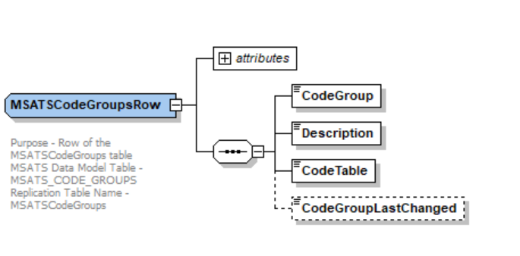

<!-- MSATS_CODES_DATED Row -->
<xsd:complexType name="MSATSCodesDatedRow">
<xsd:annotation>
<xsd:documentation>
Purpose - Row of the MSATSCodesDated table
MSATS Data Model Table - MSATS_CODES_DATED
Replication Table Name - MSATSCodesDated
</xsd:documentation>
</xsd:annotation>
<xsd:complexContent>
<xsd:extension base="ReplicationDateRangeRow">
<xsd:sequence>
<xsd:element name="CodeGroup" type="MSATSCodeGroup"/>
<xsd:element name="Code" type="MSATSCode"/>
<xsd:element name="Value" type="MSATSCodeValue" minOccurs="0"/>
<xsd:element name="Description" type="MSATSCodeValueDescription" minOccurs="0"/>
</xsd:sequence>
<xsd:attribute name="version" type="r43" use="optional" default="r43"/>
</xsd:extension>
</xsd:complexContent>
</xsd:complexType>
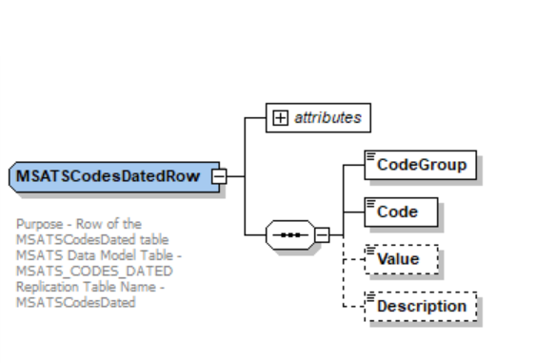

<!-- MSATS_CODE_COMBOS Row -->
<xsd:complexType name="MSATSCodeComboRow">
<xsd:annotation>
<xsd:documentation>
Purpose - Row of the MSATSCodesDated table
MSATS Data Model Table - MSATS_CODE_COMBOS
Replication Table Name - MSATSCodeCombo
</xsd:documentation>
</xsd:annotation>
<xsd:complexContent>
<xsd:extension base="ReplicationDateRangeRow">
<xsd:sequence>
<xsd:element name="CodeGroup" type="MSATSCodeGroup"/>
<xsd:element name="Code1" type="MSATSCode"/>
<xsd:element name="Code2" type="MSATSCode" nillable="true" minOccurs="0"/>
<xsd:element name="Code3" type="MSATSCode" nillable="true" minOccurs="0"/>
<xsd:element name="Code4" type="MSATSCode" nillable="true" minOccurs="0"/>
<xsd:element name="Code5" type="MSATSCode" nillable="true" minOccurs="0"/>
<xsd:element name="Value" type="MSATSCodeValue" minOccurs="0"/>
<xsd:element name="Description" type="MSATSCodeValueDescription" minOccurs="0"/>
</xsd:sequence>
<xsd:attribute name="version" type="r43" use="optional" default="r43"/>
</xsd:extension>
</xsd:complexContent>
</xsd:complexType>

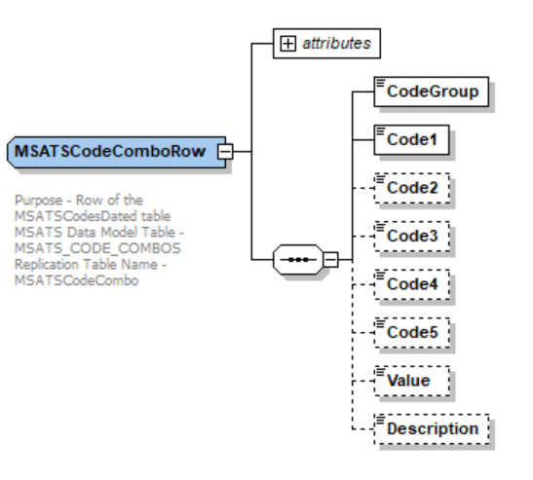

<!-- MSATS_CODES Row -->
<xsd:complexType name="MSATSCodesRow">
<xsd:annotation>
<xsd:documentation>
Purpose - Row of the MSATSCodes table
MSATS Data Model Table - MSATS_CODES
Replication Table Name - MSATSCodes
</xsd:documentation>
</xsd:annotation>
<xsd:complexContent>
<xsd:extension base="ReplicationBaseRow">
<xsd:sequence>
<xsd:element name="CodeGroup" type="MSATSCodeGroup"/>
<xsd:element name="Code" type="MSATSCode"/>
<xsd:element name="Value" type="MSATSCodeValue" minOccurs="0"/>
<xsd:element name="Description" type="MSATSCodeValueDescription" minOccurs="0"/>
</xsd:sequence>
<xsd:attribute name="version" type="r43" use="optional" default="r43"/>
</xsd:extension>
</xsd:complexContent>
</xsd:complexType>

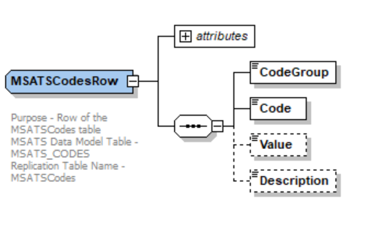

<!-- NODE_HIERARCHY Row -->
<xsd:complexType name="NodeHierarchyRow">
<xsd:annotation>
<xsd:documentation>
Purpose - Row of the NodeHierarchy table
MSATS Data Model Table - NODE_HIERARCHY
Replication Table Name - NodeHierarchy
</xsd:documentation>
</xsd:annotation>
<xsd:complexContent>
<xsd:extension base="ReplicationDateRangeRow">
<xsd:sequence>
<xsd:element name="NodeName" type="xsd:string" nillable="true" minOccurs="0"/>
<xsd:element name="NodeType" type="xsd:string"/>
<xsd:element name="ParentNodeName" type="xsd:string" minOccurs="0"/>
<xsd:element name="ParentNodeType" type="xsd:string" minOccurs="0"/>
<xsd:element name="SettlementIndicator" type="xsd:string" minOccurs="0"/>
</xsd:sequence>
<xsd:attribute name="version" type="r43" use="optional" default="r43"/>
</xsd:extension>
</xsd:complexContent>
</xsd:complexType>

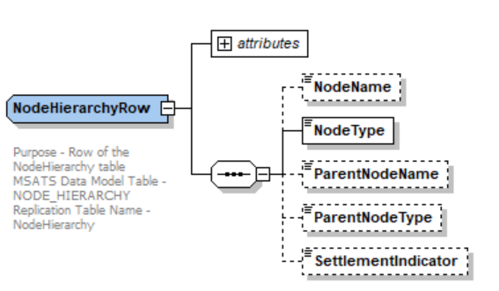

<xsd:simpleType name="MSATSCodeGroup">
<xsd:annotation>
<xsd:documentation>
MSATS Data Model Column - CodeGroup
</xsd:documentation>
</xsd:annotation>
<xsd:restriction base="xsd:string">
<xsd:maxLength value="50"/>
<xsd:minLength value="1"/>
<xsd:whiteSpace value="collapse"/>
</xsd:restriction>

<xsd:simpleType name="MSATSCode">
<xsd:annotation>
<xsd:documentation>
MSATS Data Model Column - MSATSCode
</xsd:documentation>
</xsd:annotation>
<xsd:restriction base="xsd:string">
<xsd:maxLength value="50"/>
<xsd:minLength value="1"/>
<xsd:whiteSpace value="collapse"/>
</xsd:restriction>
</xsd:simpleType>

</xsd:simpleType>

<xsd:simpleType name="MSATSCodeTableType">
<xsd:annotation>
<xsd:documentation>
MSATS Data Model Column - CodeTable
</xsd:documentation>
</xsd:annotation>
<xsd:restriction base="xsd:string">
<xsd:maxLength value="15"/>
<xsd:minLength value="1"/>
<xsd:whiteSpace value="collapse"/>
</xsd:restriction>
</xsd:simpleType>

<xsd:simpleType name="MSATSCodeValue">
<xsd:annotation>
<xsd:documentation>
MSATS Data Model Column - CodeValue
</xsd:documentation>
</xsd:annotation>
<xsd:restriction base="xsd:string">
<xsd:maxLength value="100"/>
<xsd:minLength value="1"/>
<xsd:whiteSpace value="collapse"/>
</xsd:restriction>
</xsd:simpleType>

<xsd:complexType name="ParticipantRolesRow">
<xsd:annotation>
<xsd:documentation>
Purpose - Row of the Participant Roles table
MSATS Data Model Table - CATS_Participant_Roles
Replication Table Name - ParticipantRoles
</xsd:documentation>
</xsd:annotation>
<xsd:complexContent>
<xsd:extension base="ReplicationDateRangeRow">
<xsd:sequence>
<xsd:element name="ParticipantID" type="PartyIdentifier"/>
<xsd:element name="Role" type="RoleIdentifier"/>
<xsd:element name="RoleCategory" type="RoleCategory" minOccurs="0"/>
</xsd:sequence>
</xsd:extension>
</xsd:complexContent>
</xsd:complexType>

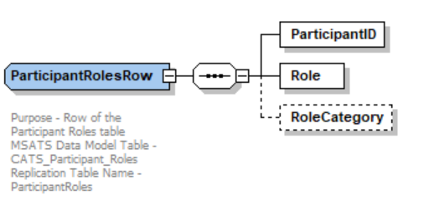

<!-- Electricity NMI Standing Data Replication Row Types -->
<xsd:complexType name="ElectricityNMIMasterRow">
<xsd:annotation>
<xsd:documentation>
Purpose - Row of the Electricity NMI Master Standing Data table
MSATS Data Model Table - CATS_NMI_Data
Replication Table Name - ElectricityNMIMaster
</xsd:documentation>
</xsd:annotation>
<xsd:complexContent>
<xsd:extension base="ReplicationDateRangeRow">
<xsd:sequence>
<xsd:element name="NMI" type="NMIBase"/>
<xsd:group ref="ElectricityNMIMasterGroup"/>
</xsd:sequence>
<xsd:attribute name="version" type="r43" use="optional" default="r43"/>
</xsd:extension>
</xsd:complexContent>
</xsd:complexType>

<!-- BDT Row Types -->
<xsd:complexType name="ElectricityNMIMasterRowBDT">
<xsd:annotation>
<xsd:documentation>
Purpose - Row of the Electricity NMI Master Standing Data table extended by BDTStatus and Event for Bulk Data Tool
MSATS Data Model Table - CATS_NMI_Data
Replication Table Name - ElectricityNMIMaster
</xsd:documentation>
</xsd:annotation>
<xsd:complexContent>
<xsd:extension base="ReplicationDateRangeRow">
<xsd:sequence>
<xsd:group ref="ElectricityNMIMasterGroup"/>
<xsd:element name="BDTStatus" type="BDTStatus" minOccurs="0"/>
<xsd:element name="Event" type="Event" minOccurs="0" maxOccurs="unbounded"/>
</xsd:sequence>
<xsd:attribute name="version" type="r43" use="optional" default="r43"/>
</xsd:extension>
</xsd:complexContent>
</xsd:complexType>

<xsd:complexType name="ElectricityCATSChangeRequestNMIMasterRow">
<xsd:annotation>
<xsd:documentation>
Purpose - Row of the Electricity CATS Change Request NMI Master Standing Data table
MSATS Data Model Table - CATS_Inbound_NMI_Data
Replication Table Name - ElectricityCATSChangeRequestNMIMaster
</xsd:documentation>
</xsd:annotation>
<xsd:complexContent>
<xsd:extension base="ReplicationBaseRow">
<xsd:sequence>
<xsd:element name="RequestID" type="CATSRequestIdentifier"/>
<xsd:group ref="ElectricityNMIMasterGroup"/>
</xsd:sequence>
<xsd:attribute name="version" type="r43" use="optional" default="r43"/>
</xsd:extension>
</xsd:complexContent>
</xsd:complexType>

Common_r43.xsd
- Added new ‘RoleCategory’ element.
- Rename file to r43 version.

<xsd:simpleType name="RoleCategory">
<xsd:annotation>
<xsd:documentation>
Purpose - Identify the role category.
MSATS Data Model Column - Role_Category
</xsd:documentation>
</xsd:annotation>
<xsd:restriction base="xsd:string">
<xsd:maxLength value="15"/>
</xsd:restriction>
</xsd:simpleType>

Electricity_r43.xsd
- Update version attribute of ‘ElectricityStandingData’ from r42 to r43
- Rename file to r43 version

<xsd:complexType name="ElectricityStandingData">
<xsd:annotation>
<xsd:documentation>
Purpose - Standing data associated with an electricity NMI.
Detail - The structure supports multiple data streams, meters and role assignments. Note that because this type is derived from the NMIStandingData type, it begins with the elements defined for that type, notably the NMI.
</xsd:documentation>
</xsd:annotation>
<xsd:complexContent>
<xsd:extension base="NMIStandingData">
<xsd:sequence>
<xsd:element name="MasterData" type="ElectricityMasterStandingData" minOccurs="0"/>
<xsd:element name="RoleAssignments" type="RoleAssignments" minOccurs="0"/>
<xsd:element name="DataStreams" type="ElectricityDataStreams" minOccurs="0"/>
<xsd:element name="MeterRegister" type="ElectricityMeters" minOccurs="0"/>
</xsd:sequence>
<xsd:attribute name="version" type="r43" use="optional" default="r43"/>
</xsd:extension>
</xsd:complexContent>
</xsd:complexType>

ElectricityMasterStandingData_r43.xsd
- Add new element ‘LastConsumerChangeDate’ to ElectricityNMIMasterGroup and ElectricityMasterStandingData
- Rename file to r43 version

<xsd:group name="ElectricityNMIMasterGroup">
<xsd:annotation>
<xsd:documentation>
Purpose - Common NMI Master elements across Standing Data and Change Requests
</xsd:documentation>
</xsd:annotation>
<xsd:sequence>
<xsd:element name="JurisdictionCode" type="JurisdictionCode" nillable="true" minOccurs="0"/>
<xsd:element name="NMIClassificationCode" type="NMIClassificationCode" nillable="true" minOccurs="0"/>
<xsd:element name="TransmissionNodeIdentifier" type="TransmissionNodeIdentifier" nillable="true" minOccurs="0"/>
<xsd:element name="DistributionLossFactorCode" type="DistributionLossFactorCode" nillable="true" minOccurs="0"/>
<xsd:element name="ParentEmbeddedNetworkIdentifier" type="EmbeddedNetworkIdentifier" nillable="true" minOccurs="0"/>
<xsd:element name="ChildEmbeddedNetworkIdentifier" type="EmbeddedNetworkIdentifier" nillable="true" minOccurs="0"/>
<xsd:element name="Address" type="AustralianPartialAddress" nillable="true" minOccurs="0"/>
<xsd:element name="Aggregate" type="YesNo" nillable="true" minOccurs="0"/>
<xsd:element name="Status" type="NMIStatusCode" nillable="true" minOccurs="0"/>
<xsd:element name="FlatOrUnitType" type="AustralianFlatOrUnitType" nillable="true" minOccurs="0"/>
<xsd:element name="FlatOrUnitNumber" type="AustralianFlatOrUnitNumber" nillable="true" minOccurs="0"/>
<xsd:element name="FloorOrLevelType" type="AustralianFloorOrLevelType" nillable="true" minOccurs="0"/>
<xsd:element name="FloorOrLevelNumber" type="AustralianFloorOrLevelNumber" nillable="true" minOccurs="0"/>
<xsd:element name="BuildingOrPropertyName" type="AustralianBuildingOrPropertyName" nillable="true" minOccurs="0"/>
<xsd:element name="BuildingOrPropertyName2" type="AustralianBuildingOrPropertyName" nillable="true" minOccurs="0"/>
<xsd:element name="LocationDescriptor" type="AustralianLocationDescriptor" nillable="true" minOccurs="0"/>
<xsd:element name="HouseNumber" type="AustralianHouseNumber" nillable="true" minOccurs="0"/>
<xsd:element name="HouseNumberSuffix" type="AustralianHouseNumberSuffix" nillable="true" minOccurs="0"/>
<xsd:element name="HouseNumberTo" type="AustralianHouseNumber" nillable="true" minOccurs="0"/>
<xsd:element name="HouseNumberToSuffix" type="AustralianHouseNumberSuffix" nillable="true" minOccurs="0"/>
<xsd:element name="HouseNumber2" type="AustralianHouseNumber" nillable="true" minOccurs="0"/>
<xsd:element name="HouseNumber2Suffix" type="AustralianHouseNumberSuffix" nillable="true" minOccurs="0"/>
<xsd:element name="LotNumber" type="AustralianLotNumber" nillable="true" minOccurs="0"/>
<xsd:element name="SectionNumber" type="SectionNumber" nillable="true" minOccurs="0"/>
<xsd:element name="DPNumber" type="DepositedPlanNumber" nillable="true" minOccurs="0"/>
<xsd:element name="StreetName" type="AustralianStreetName" nillable="true" minOccurs="0"/>
<xsd:element name="StreetType" type="AustralianStreetType" nillable="true" minOccurs="0"/>
<xsd:element name="StreetSuffix" type="AustralianStreetSuffix" nillable="true" minOccurs="0"/>
<xsd:element name="AddressLine1" type="AustralianAddressLine" nillable="true" minOccurs="0"/>
<xsd:element name="AddressLine2" type="AustralianAddressLine" nillable="true" minOccurs="0"/>
<xsd:element name="AddressLine3" type="AustralianAddressLine" nillable="true" minOccurs="0"/>
<xsd:element name="SuburbOrPlaceOrLocality" type="AustralianSuburbOrPlaceOrLocality" nillable="true" minOccurs="0"/>
<xsd:element name="StateOrTerritory" type="AustralianStateOrTerritory" nillable="true" minOccurs="0"/>
<xsd:element name="PostCode" type="AustralianPostCode" nillable="true" minOccurs="0"/>
<xsd:element name="DeliveryPointIdentifier" type="AustralianDeliveryPointIdentifier" nillable="true" minOccurs="0"/>
<xsd:element name="GNAFPID" type="GeocodedNationalAddressFilePersistentIdentifier" nillable="true" minOccurs="0"/>
<xsd:element name="DistanceFromSubstation" type="DistanceFromSubstation" nillable="true" minOccurs="0"/>
<xsd:element name="VoltageType" type="VoltageType" nillable="true" minOccurs="0"/>
<xsd:element name="PoleNumber" type="PoleNumber" nillable="true" minOccurs="0"/>
<xsd:element name="AccessDetails" type="AccessDetail" nillable="true" minOccurs="0"/>
<xsd:element name="FeederClass" type="FeederClass" nillable="true" minOccurs="0"/>
<xsd:element name="CustomerClassificationCode" type="EMSDCustomerClassificationCode" nillable="true" minOccurs="0"/>
<xsd:element name="CustomerThresholdCode" type="EMSDCustomerThresholdCode" nillable="true" minOccurs="0"/>
<xsd:element name="TransmissionNodeIdentifier2" type="TransmissionNodeIdentifier" nillable="true" minOccurs="0"/>
<xsd:element name="SharedIsolationPointFlag" type="SharedIsolationPointFlag" nillable="true" minOccurs="0"/>
<xsd:element name="MeterMalfunctionExemptionNumber" type="MeterMalfunctionExemptionNumber" nillable="true" minOccurs="0"/>
<xsd:element name="MeterMalfunctionExemptionExpiryDate" type="xsd:date" minOccurs="0"/>
<xsd:element name="ConnectionConfiguration" type="ConnectionConfiguration" nillable="true" minOccurs="0"/>
<xsd:element name="LastConsumerChangeDate" type="xsd:date" nillable="true" minOccurs="0"/>
<!-- can be skipped and have the nil value-->
</xsd:sequence>
</xsd:group>

<xsd:complexType name="ElectricityMasterStandingData">
<xsd:annotation>
<xsd:documentation>
Purpose - container for non-repeating standing data associated with an electricity NMI
</xsd:documentation>
</xsd:annotation>
<xsd:sequence>
<xsd:element name="JurisdictionCode" type="JurisdictionCode" nillable="true" minOccurs="0"/>
<xsd:element name="NMIClassificationCode" type="NMIClassificationCode" nillable="true" minOccurs="0"/>
<xsd:element name="TransmissionNodeIdentifier" type="TransmissionNodeIdentifier" nillable="true" minOccurs="0"/>
<xsd:element name="DistributionLossFactorCode" type="DistributionLossFactorCode" nillable="true" minOccurs="0"/>
<xsd:element name="ParentEmbeddedNetworkIdentifier" type="EmbeddedNetworkIdentifier" nillable="true" minOccurs="0"/>
<xsd:element name="ChildEmbeddedNetworkIdentifier" type="EmbeddedNetworkIdentifier" nillable="true" minOccurs="0"/>
<xsd:element name="Address" type="AustralianPartialAddress" nillable="true" minOccurs="0"/>
<xsd:element name="Aggregate" type="YesNo" nillable="true" minOccurs="0"/>
<xsd:element name="Status" type="NMIStatusCode" nillable="true" minOccurs="0"/>
<xsd:element name="DistanceFromSubstation" type="DistanceFromSubstation" nillable="true" minOccurs="0"/>
<xsd:element name="VoltageType" type="VoltageType" nillable="true" minOccurs="0"/>
<xsd:element name="PoleNumber" type="PoleNumber" nillable="true" minOccurs="0"/>
<xsd:element name="AccessDetails" type="AccessDetail" nillable="true" minOccurs="0"/>
<xsd:element name="FeederClass" type="FeederClass" nillable="true" minOccurs="0"/>
<xsd:element name="CustomerClassificationCode" type="EMSDCustomerClassificationCode" nillable="true" minOccurs="0"/>
<xsd:element name="CustomerThresholdCode" type="EMSDCustomerThresholdCode" nillable="true" minOccurs="0"/>
<xsd:element name="ControlEquipments" type="ControlEquipments" nillable="true" minOccurs="0"/>
<xsd:element name="NetworkDevices" type="NetworkDevices" nillable="true" minOccurs="0"/>
<xsd:element name="EnergisationStatus" type="EnergisationStatus" nillable="true" minOccurs="0"/>
<xsd:element name="PrimaryVoltage" type="PrimaryVoltage" nillable="true" minOccurs="0"/>
<xsd:element name="FromDate" type="xsd:date" minOccurs="0"/>
<xsd:element name="ToDate" type="xsd:date" minOccurs="0"/>
<xsd:element name="TransmissionNodeIdentifier2" type="TransmissionNodeIdentifier" nillable="true" minOccurs="0"/>
<xsd:element name="SharedIsolationPointFlag" type="SharedIsolationPointFlag" nillable="true" minOccurs="0"/>
<xsd:element name="MeterMalfunctionExemptionNumber" type="MeterMalfunctionExemptionNumber" nillable="true" minOccurs="0"/>
<xsd:element name="MeterMalfunctionExemptionExpiryDate" type="xsd:date" nillable="true" minOccurs="0"/>
<xsd:element name="ConnectionConfiguration" type="ConnectionConfiguration" nillable="true" minOccurs="0"/>
<xsd:element name="LastConsumerChangeDate" type="xsd:date" nillable="true" minOccurs="0"/>
<!--confirm element name-->
</xsd:sequence>
</xsd:complexType>

Events_r43.xsd
- New file to replace Events_r42.xsd and include the r42 release identifier as below:

<xsd:simpleType name="r43">
<xsd:annotation>
<xsd:documentation>Purpose - Release r43 identifier.</xsd:documentation>
</xsd:annotation>
<xsd:restriction base="ReleaseIdentifier">
<xsd:enumeration value="r43"/>
</xsd:restriction>
</xsd:simpleType>

MDMTReports_r43.xsd
- Define new complex element ‘MDMTSettlementCaseDetailsReportParameters’ for the new Regulated SAPS Generator Reconciliation report

<xsd:complexType name="MDMTSettlementCaseDetailsReportParameters">
<xsd:annotation>
<xsd:documentation>
Purpose - Parameter definition for SAPS Reconciliation
Report Name - RegulatedSAPSGenerationReconcilation
MSATS Reports - RM51
</xsd:documentation>
</xsd:annotation>
<xsd:complexContent>
<xsd:extension base="BaseReportParameters">
<xsd:sequence>
<xsd:element name="SettlementCase" type="MDMSettlementCaseIdentifier"/>
<xsd:element name="ProfileArea" type="ProfileDescription" minOccurs="0"/>
<xsd:element name="TransmissionNodeIdentifier" type="TransmissionNodeIdentifier" minOccurs="0"/>
<xsd:element name="NMI" type="NMIBase" minOccurs="0"/>
</xsd:sequence>
</xsd:extension>
</xsd:complexContent>
</xsd:complexType>

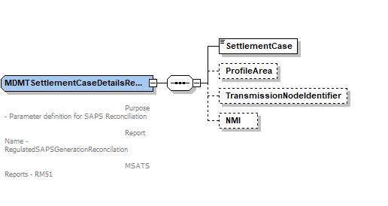

OneWayNotification_r43.xsd
- Add new element ‘SharedFuseNotification’
- Rename file to r43 version

<xsd:complexType name="SharedFuseNotification">
<xsd:sequence>
<xsd:element name="NMI" type="NMI" />
<xsd:element name="IdentifiedDate" type="xsd:date"/>
<xsd:element name="SharedIsolationPointFlag" type="SharedIsolationPointFlag"/>
</xsd:sequence>
<xsd:attribute name="version" type="r43" use="optional" default="r43"/>
</xsd:complexType>

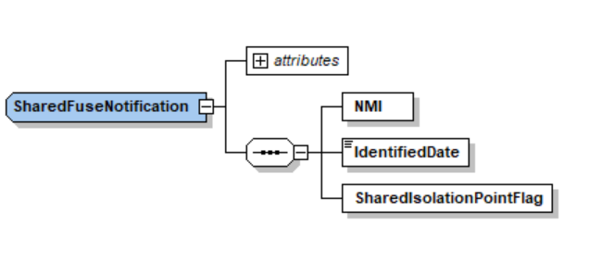

Transactions_r43.xsd
- Added new B2B transaction ‘SharedFuseNotification’ to ‘Transaction’ element.
- Rename file to r43 version

<xsd:complexType name="Transaction">
<xsd:annotation>
<xsd:documentation>
Purpose - Common container for all transactions
Detail - All transactions within aseXML are carried within this container. The transactionID and transactionDate are provided for all transactions. The initiatingTransactionID is only provided on response transactions and represents the transactionID of the initiating transaction.
</xsd:documentation>
</xsd:annotation>
<xsd:choice>
<xsd:element name="ReplicationRequest" type="ReplicationRequest"/>
…
…
…
<xsd:element name="OneWayNotification" type="OneWayNotification"/>
<xsd:element name="SharedFuseNotification" type="SharedFuseNotification"/>
…
…
…
<xsd:element name="LifeSupportNotification" type="LifeSupportNotification"/>
<xsd:element name="LifeSupportRequest" type="LifeSupportRequest"/>
</xsd:choice>
<xsd:attribute name="transactionID" type="TransactionIdentifier" use="required"/>
<xsd:attribute name="transactionDate" type="xsd:dateTime" use="required"/>
<xsd:attribute name="initiatingTransactionID" type="TransactionIdentifier" use="optional"/>
</xsd:complexType>

Schema Manifest
The table below shows the schema files included in this release. Files that have been added, removed or modified for this release are marked.
- Schema Files
File | Modified
Acknowledgements_r15.xsd
aseXML_r43.xsd | *
BAR_r31.xsd
BulkDataTool_r33.xsd
CATSReports_r39.xsd
CATSTableReplication_r43.xsd | *
ClientInformation_r42.xsd
Common_r43.xsd | *
CustomerDetails_r41.xsd
CustomerTransfer_r29.xsd
ElectricityEnumerations.xsd
ElectricityHighSpeedMonitoring_r26.xsd
ElectricityMasterStandingData_r43.xsd | *
ElectricityMMS_r33.xsd
Electricity_r43.xsd | *
Enumerations.xsd
Events_r43.xsd | *
Faults_r33.xsd
GasEnumerations.xsd
GasMarketWholesale_r34.xsd
Gas_r40.xsd
Header_r37.xsd
HighSpeedMonitoring_r33.xsd
HubManagement_r37.xsd
MarketWholesale_r20.xsd
MDMTReports_r43.xsd | *
MeterDataManagement_r36.xsd
NetworkBilling_r34.xsd
NMIDataAccess_r39.xsd
NOSAssessment_r38.xsd
NOSBooking_r38.xsd
NOSCommon_r38.xsd
NOSEquipment_r33.xsd
OneWayNotification_r43.xsd | *
P2P_r36.xsd
Reports_r39.xsd
ServiceOrder_r41.xsd
TableReplication_r33.xsd
Transactions_r43.xsd | *

Schema Test

Test
The ASWG ensures that all recommended parsers on relevant platforms can successfully validate the proposed schema.

Test Platforms
Supplied samples have been tested using the following parsers:
- XMLSpy
- MSXML6
- Xerces 2.9.1
- Xerces 2.2.1
- Schema comparison (r42 - r43)

Test Cases
- NOTE: Sample filenames have been modified, where they contained a space in the name, as these failed Xerces validation

Test Process
- Obtain a copy of the 5 existing regression test suite XML files
  - nem_samples_r42.zip
  - nem_wholesale_samples_r42.zip
  - nemb2b_samples_r42.zip
  - sawa_samples_r42.zip
  - vicgas_samples_r42.zip
- Obtain a copy of new R42 test suite XML files.
- Unzip all test XML files a folder
- Replace “xmlns:ase="urn:aseXML:r42” with “xmlns:ase="urn:aseXML:r43”
- Replace “xsi:schemaLocation="urn:aseXML:r42 http://www.nemmco.com.au/aseXML/schemas/r42/aseXMLr42.xsd” with “xsi:schemaLocation="urn:aseXML:r43 S:/aseXML_r43.xsd” where S: is a mapped local folder holding the r43 schema files.
- Check every single test XML file individually to detect variances in the above xsi:schemaLocation approach, e.g. hardcoded “O:/<filename>” instances and other occurrences not picked up by the standard search/replace above need to be manually fixed. It would be good if a single search/replace could be used for this step, and the test XML files had consistent headers.
- Run the test process using the 4 supported XML Toolkits.
- Check output log for any successful parse results, as well as expected or unexpected errors.

Test Results
All OK on all Test Platforms, see section 6.1.1
- All valid test files passed with no parse error.

Character Classification
Pattern restriction is enforced by regular expressions in some places in aseXML schema. That makes knowing the precise set of classification of characters important. It is particularly important in the testing process. In some quick tests using simple Pattern class in JAVA – not fully fledged JAVA parsers – some differences vis-à-vis XML Spy were reported. These tests were performed to validate the data stored in database against aseXML type definitions. Some characters that were treated differently between JAVA Pattern class and XML Spy were $ + |. XML Spy accepted them as punctuation characters but JAVA Pattern class rejected. Note, these three characters are only a few examples of difference, not an exhaustive list. As explained below, further investigations revealed that XML Spy is correct as per the XML standard.

The XML standards depend upon Unicode specifications for the purpose of this classification. The complete list of classification of Unicode characters in various classes can be found at http://www.unicode.org/.

To download the classification for any particular version of classification, start from directory listing at http://www.unicode.org/Public and traverse down the tree of the concerned version to download the zip (usually named ucd.zip) which contains all the documents for that version. The zip for version 6.2.0 resides at http://www.unicode.org/Public/6.2.0/ucd/. The document in this zip, usually named UnicodeData.txt, contains entire classification of all Unicode characters, having a line per Unicode character, with semi-colon delimited fields in each line. Explanation of fields can be found in the documentation in the zip (UCD.html). To view this UnicodeData.txt document conveniently, start Excel and open the document. While opening the document Excel will ask for information about the file contents. In response specify the document to be semicolon delimited with each column of the document being text. The column C of the Excel spreadsheet specifies the character classification. Note, while opening the file in Excel if each column is not specified to be text then Excel may format some information incorrectly.

The classification of the extended ASCII characters for version 6.2.0 of Unicode is provided here in an Excel spreadsheet :

The classifications starting with L signify letters, starting with N signify digits, starting with P signify punctuations, starting with S signify symbols and those starting with C signify control characters. Note, the spread sheet does not contain all the fields (columns) from the UnicodeData.txt file.

ASWG Endorsement
With a quorum established the ASWG voted to endorse schema r43, with the included aseXML Change Requests. The voting results are forwarded to AEMO for approval. When 75% of those ASWG members vote to endorse a schema it represents an ASWG recommendation for that schema. AEMO will not reject an ASWG recommendation without first consulting with the ASWG.

The results of the ASWG vote for the final schema to be released are as follows:
Date of Vote: 14/05/2021
Option | # Votes | % Vote
For | 4 | 100%
Against | 0 | 0%
Abstained | 0 | 0%
Total Members Present | 4 | 100%

AEMO Approval
The schema approval and approval date are identified below

Status | Date | Authorised by
Approved – The schema has been approved by AEMO and is formally released for use

Change Type can be one of - New - Enhancement, or - Bug Fix

