Attachment A – information INCLUDING CONSOLIDATED FEEDBACK FROM GMI / participant PPC response template.
Responses to be emailed to grcf@aemo.com.au by Monday 8 February 2021.
Review comments submitted by: <insert company>  Contact Person: <insert contact person> |  |  |  |  | Date: <insert date>
# | IN002/18 | Description | Add a provision that describes that AEMO can lodge a transfer on behalf of a SCU as per SA RMP. This was raised by AEMO as part of SA RMP harmonisation (IN006/17).
Source document |  |  | Ref 1 - Retail Market Procedure (SA)
Source section ref |  |  | Was SA RMP clause 1.3.6. Now clause 6.2.1
Participant comments on updated document |  |  | <provide any comments here>
The following documents that have been updated
Updated document |  |  | Ref 2 - Retail Market Procedure (NSW/ACT)
Updated section ref |  |  | NSW/ACT RMP clause 6.2.1 ( e)
Participant comments on updated document |  |  | <provide any comments here>
Updated document |  |  | Ref 3 - Retail Market Procedure (QLD)
Updated section ref |  |  | QLD RMP clause 4.1.1 ( e)
Participant comments on updated document |  |  | <provide any comments here>
Updated document |  |  | Ref 4 - Retail Market Procedure (VIC)
Updated section ref |  |  | VIC RMP clause 4.1.1 ( e)
Participant comments on updated document |  |  | <provide any comments here>
GMI Feedback |  |  | SA RMP:  AGL - Noting that the additional SCU Transfer Request clauses have been added to the section on Transfer Requests in the NSW, Vic and Qld procedures, AGL suggests for consistency that the SA clause (1.3.6) be deleted and the contents relocated to become part of Cl 6.2.1 Transfer Request  as part of this harmonisation process.  AEMO Response – AEMO supports this proposal)  NSW/ACT RMP  AGL - Noted and Agree  QLD RMP  AGL - Noted and Agree  VIC RMP  AGL - Noted and Agree  Multinet – No issue
Background
Not applicable.

# | IN004/17 | Description | Add a downgrade process to the RMPs. This was raised by AGL as part of minor changes to the gas RMP to support to harmonisation (IN027/14). See below for further background information.
Source document |  |  | Ref 2 - Retail Market Procedure (NSW/ACT)
Source section ref |  |  | NSW/ACT clause 4.3
The following documents that have been updated
Updated document |  |  | Ref 1 - Retail Market Procedure (SA)
Updated section ref |  |  | SA RMP clause 4.3
Participant comments on updated document |  |  | <provide any comments here>
Updated document |  |  | Ref 3 - Retail Market Procedure (QLD)
Updated section ref |  |  | QLD RMP clause 2.9.3A
Participant comments on updated document |  |  | <provide any comments here>
Updated document |  |  | Ref 4 - Retail Market Procedure (VIC)
Updated section ref |  |  | VIC RMP clause 2.9.3A
Participant comments on updated document |  |  | <provide any comments here>
GMI feedback |  |  | SA RMP -  AGL - AGL notes that only the SA procedures retains the following relocated clause (e)  (e) Nothing in this clause 4.3 permits a User to do anything it is not permitted by law or a contract other than these Procedures to do.  This clause has not been replicated in the other procedures and AGL does not consider it adds value to the SA procedures as the SA clause relates to a request to the Network Operator and therefore suggests that it be deleted. If there is concern associated with a User request to the Network Operator, then AGL suggests this be resolved, and the updated drafting be used in all procedures. (AEMO Response – AEMO supports this proposal)  AGN - d) Where an interval meter is downgraded to an basic meter by a Network Operator, the Network Operator must use its reasonable endeavours:  (i) to provide to AEMO all the relevant details relating to the basic meter required for the purposes of updating the AEMO metering database by 5.00 pm on the 2nd business day after the day on which the meter was downgraded; and  (ii) to include the relevant details relating to the basic meter in its metering database by 5.00pm on the 5th business day after the day on which the meter was upgradeddowngraded  (AEMO Response – AEMO will correct these minor typo’s )  QLD RMP  AGL - Noted and Agree  AGN - Some corrections required…  2.9.3A Meter Upgrade or Downgrade  (a) A User who is the FRO or prospective FRO who has received explicit informed consent from the subject Customer for a distribution supply point that is located in the distribution region of Distributor may request that Distributor to:  (i) upgrade a basic meter at that distribution supply point to an interval meter, or  (ii) downgrade an interval meter at that distribution supply point to a basic meter.  (b) The Distributor must use reasonable endeavours to complete an upgrade to an interval meter or downgrade to a basic meter as requested under paragraph (a) within 40 business days after the day on which that request was delivered to the Distributor.  (c) Where a basic meter is upgraded to an interval meter by a Distributor, the Distributor must use its reasonable endeavours:  (i) to provide to AEMO all the relevant details relating to the interval meter which are required for the purposes of updating the AEMO meter register; and  (ii) to include the relevant details relating to the interval meter in its installation database, its MIRN database and its meter data database, by 5.00pm on the 5th business day after the day on which the meter was upgraded; and  (d) Where an interval meter is downgraded to an basic meter by a Distributor, the Distributor must use its reasonable endeavours:  (iii) to provide to AEMO all the relevant details relating to the basic meter which are required for the purposes of updating the AEMO meter register; and  (iv) to include the relevant details relating to the basic meter in its installation database, its MIRN database and its meter data database, by 5.00pm on the 5th business day after the day on which the meter was downgraded  (AEMO Response – AEMO will correct these minor typo’s )  VIC RMPs  AGL- Noted and Agree  Multinet - Spelling check required  For Multinet Gas it is not possible to meet the 5-day obligation to have DB systems updated after an interval downgrade as the final meter data for billing this interval account is not received from AEMO until the 18th business day the month AFTER it was read. To downgrade the meter to a basic meter Multinet Gas need to have billed this account for the interval period up to the downgrade date. Therefore, it is possible that the meter can be downgraded in the market but MGN is not able to process until it has been invoiced for the month prior.  (AEMO Response – To address the matter raised by Multinet AEMO has updated the VIC RMP so that 5 Business Days starts from the receiving of the interval meter meter reading from AEMO rather than change over on the meter itself.)  AGN –  Some corrections required…  (a) A Retailer who is the FRO or prospective FRO who has received explicit informed consent from the subject Customer for a distribution supply point that is located in the distribution area of a Distributor may request that Distributor to:  - upgrade a basic meter at that distribution supply point to an interval meter, or  - (ii) downgrade an interval meter at that distribution supply point to a basic meter. (b) The Distributor must use reasonable endeavours to complete an upgrade to an interval meter or downgrade to a basic meter as requested under paragraph (a) (and commission or decommission any associated data reading infrastructure in cooperation with AEMO) within 20 business days after the day on which that request was delivered to the Distributor.  (c) Where a basic meter is upgraded to an interval meter by a Distributor, the Distributor must use its reasonable endeavours:  (i) to provide to AEMO all the relevant details relating to the interval meter which are required for the purposes of updating the AEMO meter register; and  (ii) to include the relevant details relating to the interval meter in its installation database, its MIRN database and its meter data database, by 5.00pm on the 5th business day after the day on which the meter was upgraded; and  (d) Where an interval meter is downgraded to an basic meter by a Distributor, the Distributor must use its reasonable endeavours:  (i) to provide to AEMO all the relevant details relating to the basic meter which are required for the purposes of updating the AEMO meter register; and  (ii) to include the relevant details relating to the basic meter in its installation database, its MIRN database and its meter data database, by 5.00pm on the 5th business day after the day on which the meter was downgraded.  (AEMO Response – AEMO will correct these minor typo’s )
Background
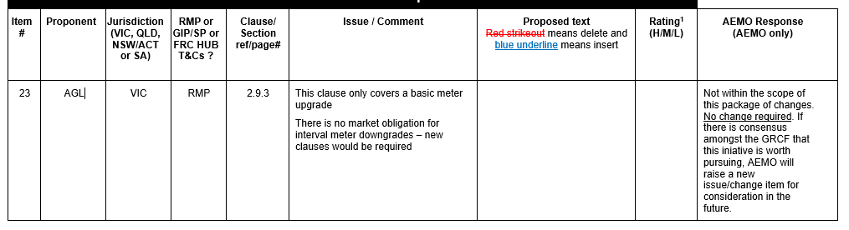

# | IN004/19 | Description | The NSW/ACT RMP should be updated to reference number of hours “from the start of the gas day” like the other the jurisdiction. This was raised by AGL as part of the gas day harmonisation consultation (IN002/16). See below for further background information.
Updated document |  |  | Ref 3 - Retail Market Procedure (QLD)
Source section ref |  |  | Clause 10.1.1
The following documents that have been updated
Updated document |  |  | Ref 2 - Retail Market Procedure (NSW/ACT)
Updated section ref |  |  | clauses: 7.2.1, 8.11.1, 8.11.2, 8.11.3, 8.11.4, 8.11.6, 8.11.7, 8.11.7, 8.12.1, 8.12.3
Participant comments on updated document |  |  | <provide any comments here>
GMI feedback |  |  | AGL - Noted and Agree  AEMO – For the SA and NSW/ACT RMP, added the words “that commences” after the words gas day. See IN007/19
Background
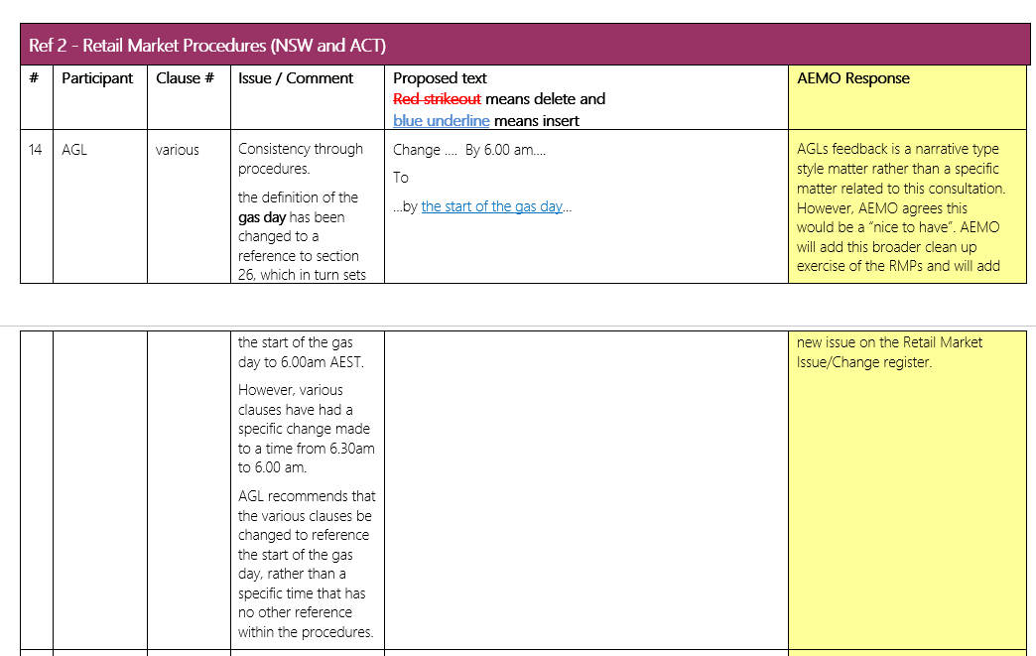

# | IN005/19 and IN003/21 | Description | Remove redundant transitional provision in Chapter 12A. This was raised by AGL as part of the gas day harmonisation consultation (IN002/16). See below for further background information.
Source document |  |  | Not Applicable
Source section ref
The following documents that have been updated
Updated document |  |  | Ref 2 - Retail Market Procedure (NSW/ACT)
Updated section ref |  |  | Chapter 12A and B
Participant comments on updated document |  |  | <provide any comments here>
Updated document |  |  | Ref 3 - Retail Market Procedure (QLD)
Updated section ref |  |  | Chapter 12
Participant comments on updated document |  |  | <provide any comments here>
GMI feedback |  |  | AGL - Noted and Agree.  AGL also suggests that the transitional provisions for the Gas Day Harmonisation could also be deleted;  • NSW/ACT Procedures – Chapter 12B  • Queensland Procedures - Chapter 12.1  (AEMO Response – On the basis that AGL proposal to remove Gas Day Harmonisation transitionals is similar to the scope of IN005/19, AEMO has to add this change to the register (see IN003/21) and included this change in the scope of works for IN004/17)
Background

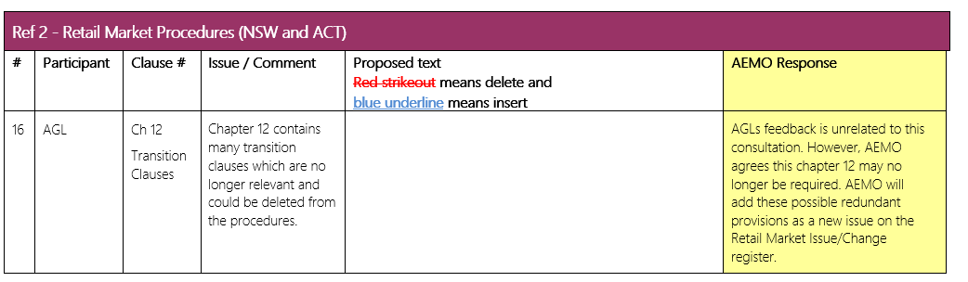

# | IN005/20 | Description | Review of RMPs address based identifiers process to determine if the WA change needs to be applied to other jurisdictions. This was raised by AGL and OE as part of the adding a address attribute change process in WA (IN003/18). See below for further background information.
Source document |  |  | Ref 5 - Retail Market Procedure (WA)
Source section ref |  |  | WA RMP clause 14 (5)
The following documents that have been updated
Updated document |  |  | Ref 1 - Retail Market Procedure (SA)
Updated section ref |  |  | SA clause 1.3.3
Participant comments on updated document |  |  | <provide any comments here>
Updated document |  |  | Ref 2 - Retail Market Procedure (NSW/ACT)
Updated section ref |  |  | NSW/ACT clause 1.3.3
Participant comments on updated document |  |  | <provide any comments here>
Updated document |  |  | Ref 3 - Retail Market Procedure (QLD)
Updated section ref |  |  | QLD clause 1.3.1
Participant comments on updated document |  |  | <provide any comments here>
Updated document |  |  | Ref 4 - Retail Market Procedure (VIC)
Updated section ref |  |  | VIC RMP 1.2.2
Participant comments on updated document |  |  | <provide any comments here>
GMI feedback |  |  | SA RMPS  AGL - Noted, however, AGL refers to its submission (Oct 2018 below) and the trigger for requesting a change is the inclusion of the word ‘needed’ in the introductory phrase:  If a User or Network Operator or AEMO becomes aware of an addition needed to the aseXML Schema enumerated  AGL noted that without this addition, the introduction reads as though there is an addition of a change to the schema which is then notified to parties.  This drafting was part of the WA procedures and should be included in the remaining redrafting of the other Procedures.  (AEMO Response – The word “needed” was mistaken overlooked by AEMO. It has been added so the clause now aligns with WA.)  NSW/ACT RMPs  AGL - Noted, however, AGL refers to its submission (Oct 2018 below) and the trigger for requesting a change is the inclusion of the word ‘needed’ in the introductory phrase:  If a User or Network Operator or AEMO becomes aware of an addition needed to the aseXML Schema enumerated  AGL noted that without this addition, the introduction reads as though there is an addition of a change to the schema which is then notified to parties.  This drafting was part of the WA procedures and should be included in the remaining redrafting of the other Procedures to ensure consistency.  AEMO Response – The word “needed” was mistaken overlooked by AEMO. It has been added so the clause now aligns with WA.)  QLD RMPs  AGL - Noted, however, AGL refers to its submission (Oct 2018 below) and the trigger for requesting a change is the inclusion of the word ‘needed’ in the introductory phrase:  If a User or Network Operator or AEMO becomes aware of an addition needed to the aseXML Schema enumerated  AGL noted that without this addition, the introduction reads as though there is an addition of a change to the schema which is then notified to parties.  This drafting was part of the WA procedures and should be included in the remaining redrafting of the other Procedures to ensure consistency.  AEMO Response – The word “needed” was mistaken overlooked by AEMO. It has been added so the clause now aligns with WA.)  VIC RMPs  AGL - Noted, however, AGL refers to its submission (Oct 2018 below) and the trigger for requesting a change is the inclusion of the word ‘needed’ in the introductory phrase:  If a User or Network Operator or AEMO becomes aware of an addition needed to the aseXML Schema enumerated  AGL noted that without this addition, the introduction reads as though there is an addition of a change to the schema which is then notified to parties.  This drafting was part of the WA procedures and should be included in the remaining redrafting of the other Procedures to ensure consistency.  AEMO Response – The word “needed” was mistaken overlooked by AEMO. It has been added so the clause now aligns with WA.)  Multinet - No comment
Background

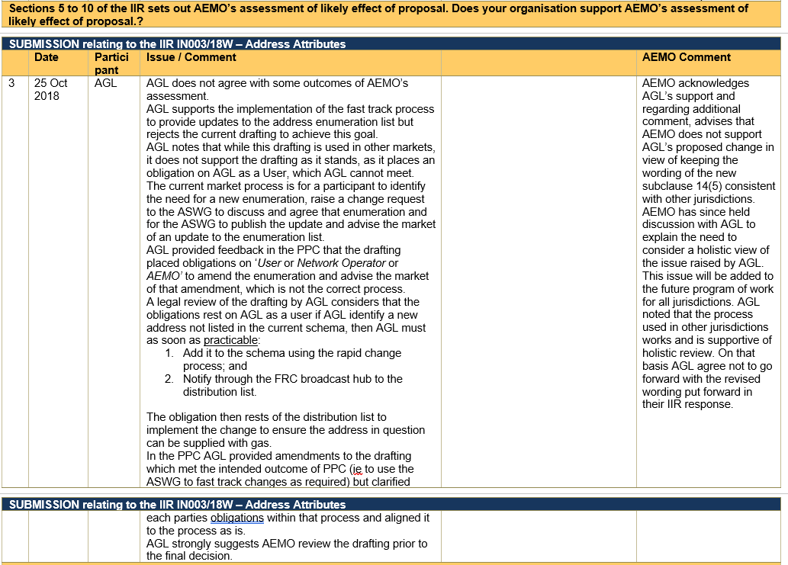
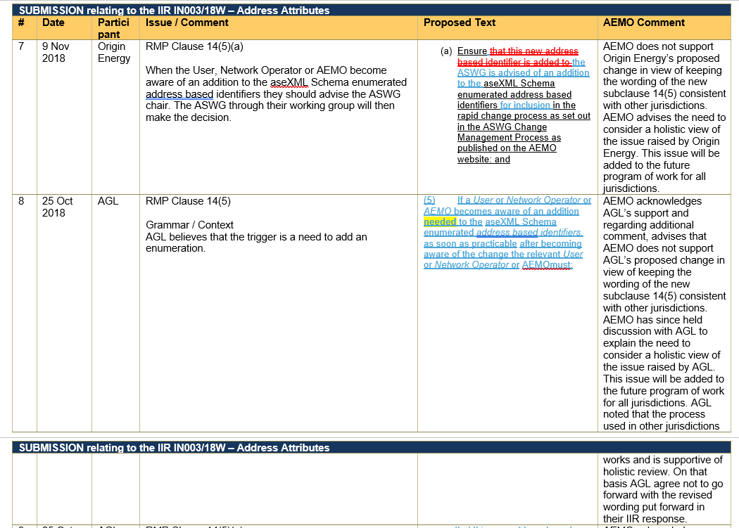
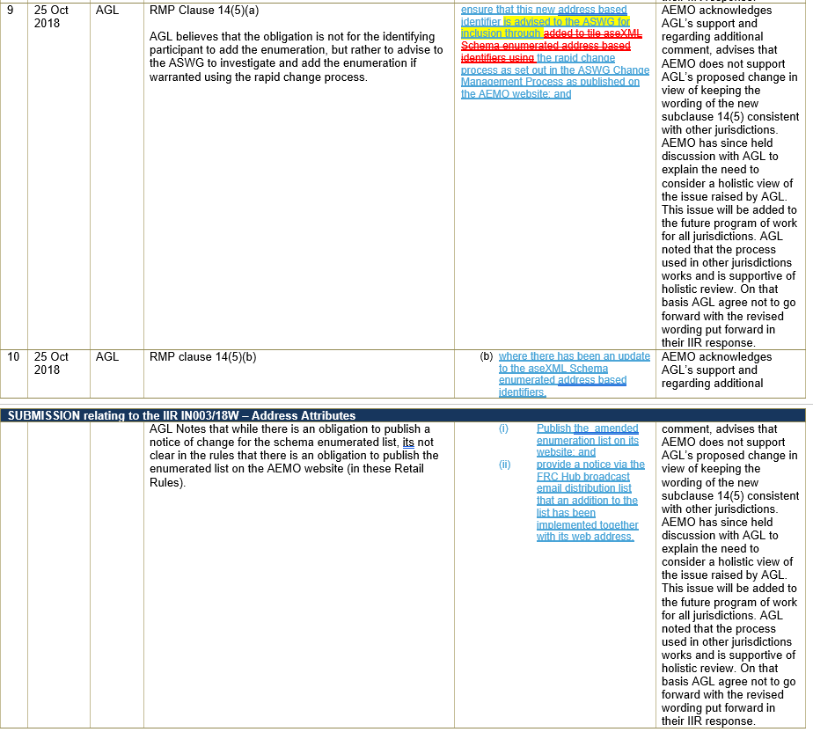

# | IN007/19 | Description | Cls 7.2.1 do not have a clear time for the cancelled or accelerated transfer actions to occur whereas the other jurisdictions do. This was raised by AGL as part of the gas day harmonisation consultation (IN002/16). See below for further background information.
Source document |  |  | Ref 2 - Retail Market Procedure (NSW/ACT)
Source section ref |  |  | NSW/ACT RMP clause 7.2.1
The following documents that have been updated
Updated document |  |  | Ref 1 - Retail Market Procedure (SA)
Updated section ref |  |  | SA RMP clause 7.2.1
Participant comments on updated document |  |  | <provide any comments here>
GMI feedback |  |  | AGL - Noted and Agree  AEMO – For the SA and NSW/ACT RMP, added the words “that commences” after the words gas day.
Background
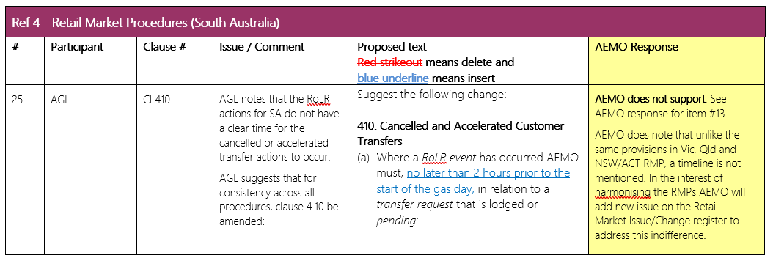

# | IN008/18 | Description | All jurisdiction RMPs state that AEMO can submit a MIRN discovery request however the method and format isn’t specified in any technical protocol. This was raised by AEMO.
Source document |  |  | Not Applicable
Source section ref
The following documents that have been updated
Updated document |  |  | VIC  Ref 6 - Participant Build Pack 1 - Process Flow Table of Transactions  Ref 7 - Participant Build Pack 1 - CSV Data Format Specifications
Updated section ref |  |  | See Table of Transaction tab. See section 6.6A
GMI feedback |  |  | AGL - The T282 Transaction has all elements listed as Optional, but no support note requiring either NMI/Checksum or Address to enable a search to be undertaken.  AGL would suggest that a note is included to ensure that the necessary information is provided to ensure the Network Operator is able to undertake a MRN Discovery search.  (AEMO Response – AEMO supports AGL suggestion to add further text that either NMI/Checksum or Address is required. The CSV Data Format Specifications document has been updated.)  T283 also makes the address mandatory, however if there is no MIRN there can be no address. It is unclear what the response is if the MIRN is incorrect, as there is no invalid request response.  AGL also notes that other fields such as Transmission Zone, Heating Value Zone and MIRN status are not required to be populated if a meter is attached, although Clause 3.3.1 requires the data to be provided. AGL suggests the table be amended and a ‘No MIRN’ response also be defined. AEMO Response – AEMO supports AGL suggestion and added further text to the CSV Data Format Specifications document)  Multinet – No comment  AGN - General comment for all jurisdictions – we are not aware of having received these requests from AEMO in the past. Can AEMO confirm please that the intention of these changes is only to align the technical protocols with the current RMPs, rather than a change in practice where MIRN discovery requests from AEMO could become commonplace? What would be the purpose of such requests from AEMO?  (AEMO Response – This transaction is very unlikely to become common place. One likely scenario is if a SCU was unaware of their MIRN as AEMO needs to submit a transfer request behalf of the SCU.
Updated document |  |  | QLD  See VIC changes
Updated section ref
GMI feedback |  |  | AGL - See comments on Vic PBP changes.
Updated document |  |  | NSW/ACT  Ref 8 - Participant Build Pack 5 - NSW-ACT and Ref 9 - Participant Build Pack 6 - NSW-ACT
Updated section ref |  |  | Section 3.1 and Section 3.1.1
GMI feedback |  |  | AGL - Noted. For Build Pack 6 there is an inconsistent use of n/a and N/A within the table, and n/a or N/A is not defined in the table (for consistency with NC and NR).  AEMO Response – AEMO supports AGL suggestion to add further clarity to the mean of N/A).
Updated document |  |  | SA  Ref 10 - FRC B2B System Interface Definitions
Updated section ref |  |  | Appendix F
GMI feedback |  |  | AGL - Unlike the Victorian T282 Transaction, the SA T282 transaction does not include the NMI Checksum, and does not clarify which combination of elements is required to be provided to ensure the Network Operator is able to undertake a MRN Discovery search.  The T283 transaction also does not specify a response for an incorrect MIRN nor any elements which may be optional or case specific.
Background
Not Applicable

# | IN009/15 | Description | Include defined terms for NERL if they are mentioned in RMPs. This was raised by AGL as part of NARGP. See below for further background information.
Source document |  |  | Not applicable.
Source section ref
The following documents that have been updated
Updated document |  |  | Ref 3 - Retail Market Procedure (QLD)
Updated section ref
Participant comments on updated document |  |  | <provide any comments here>
GMI feedback |  |  | AGL - Noted and Agree
Background
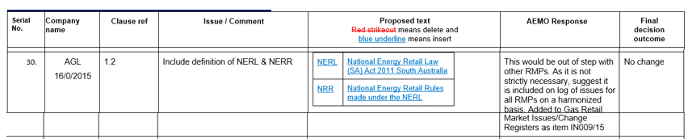

# | IN009/17 & IN015/15 | Description | Add a cause 4.2A (Re-energisation of Distribution Supply Points) to align with Qld and Vic. See Qld clause 2.9.5A. This was raised by Red/Lum as part of minor changes to the gas RMP to support to harmonisation (IN027/14). See below for further background information.
Source document |  |  | Ref 3 - Retail Market Procedure (QLD)
Source section ref |  |  | QLD RMP clause 2.9.5A
The following documents that have been updated
Updated document |  |  | Ref 2 - Retail Market Procedure (NSW/ACT)
Updated section ref
Participant comments on updated document |  |  | <provide any comments here>
GMI feedback |  |  | AGL - Noted and Agree
Background

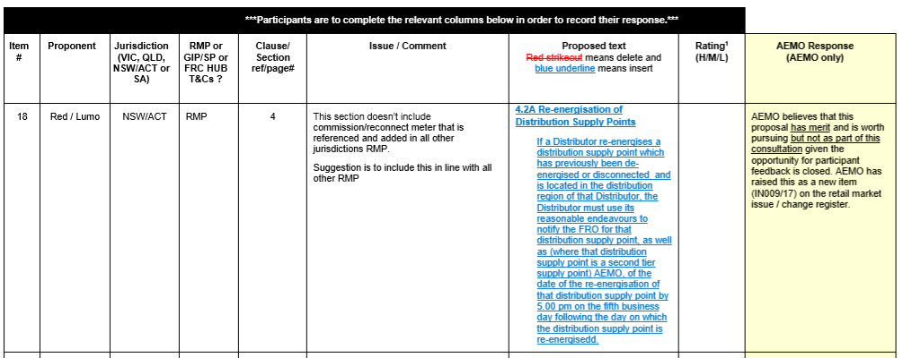

# | IN009/20 | Description | Appendix D (The Low Volume Interface) of the FRC B2M-B2B Hub System Specifications need to be amended to say “WA only”. This was raised by AEMO.
Source document |  |  | Not Applicable
Source section ref
The following documents that have been updated
Updated document |  |  | SA  Ref 11 - FRC B2M-B2B Hub System Specifications
Updated section ref
Participant comments on updated document |  |  | <provide any comments here>
GMI feedback |  |  | AGL - This change is unclear, noting that the comment says that the LVI is available for SA participants.  (AEMO Response – The comment has been corrected to say LVI is not available in SA)
Background

# | IN010/15 | Description | Recommend removal of the word ‘calendar’ before day as it causes confusion about the definition of ‘day’ which is currently undefined. This was raised by Red/Lumo and EA as part of NARGP. See below for further background information
Source document
Source section ref
The following documents that have been updated
Updated document |  |  | Ref 1 - Retail Market Procedure (SA)
Updated section ref |  |  | 5.2.1, 5.2.2, 7.1, 7.2.8, 8.4.2
Participant comments on updated document |  |  | <provide any comments here>
Updated document |  |  | Ref 2 - Retail Market Procedure (NSW/ACT)
Updated section ref |  |  | See 1.2.1, 5.2.1, 5.2.2, 7.2.6, 8.8.6, 8.9.13,8.9.17, A2.2, A3.3
Participant comments on updated document |  |  | <provide any comments here>
Updated document |  |  | Ref 3 - Retail Market Procedure (QLD)
Updated section ref |  |  | 1.1.1, 2.9.7, 3.1.1, 3.3.2, 6.3, 6.4.1, ,6.5.2, 7.7, 9.1, 10.1.6, 10.1.9, 11.6.1
Participant comments on updated document |  |  | <provide any comments here>
Updated document |  |  | Ref 4 - Retail Market Procedure (VIC)
Updated section ref |  |  | See 2.9.7, 3.3.1, 3.3.1A, 5.1.1 6.1.5, 6.1.7
Participant comments on updated document |  |  | <provide any comments here>
GMI feedback |  |  | SA RMPS  AGL - Change noted, although a definition of ‘Day’ and ‘Month’ would provide completeness.  (AEMO Response – AEMO does not support AGL idea to add definition in the RMPs for “Day” and “Month” as the meaning for these words don’t vary from the meaning that would be prescribed in a dictionary).  NSW/ACT  AGL - See above – SA Comment. (AEMO Response – See above SA AEMO response)  AGL is unclear why Calendar is not deleted from Appendix A2.3(b)(ii) or A3.3(d), although it Is deleted from other appendices, and suggest it be delated from these clauses for completeness.  (AEMO Response – AEMO support AGL’s additional deletion. These were overlooked by AEMO in the original review)  QLD RMPs  AGL - See above – SA Comment (AEMO Response – See above SA AEMO response)  VIC RMPs  AGL - See above - SA Comment.  AGL notes that calendar is not deleted in cl 2.8.4 when preceding the word ‘year’ as it has been in this and other procedures and suggests that it be deleted for consistency.  AEMO Response – AEMO support AGL’s additional deletion. These were overlooked by AEMO in the original review)  General comments - AGL also notes that the proposal was to delete the word ‘calendar’ before the word ‘day’ to reduce confusion with ‘business day’, however, the majority of deletions across these procedural changes are to delete the word ‘calendar’ before ‘month’ which is a separate issue.  Multinet - No comment
Background
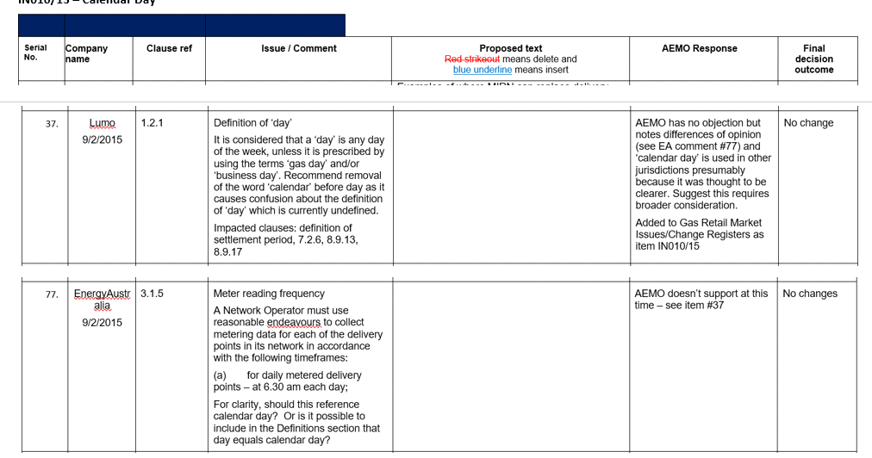

# | IN013/15 | Description | AEMO introduced the defined term “Prospective FRO” in NSW/ACT. This is a term not used other jurisdictions. For consistency AEMO proposed to also add this definition in VIC and QLD. This was raised by Red/Lumo and EA as part of NARGP. See below for further background information.
Source document |  |  | Ref 2 - Retail Market Procedure (NSW/ACT)
Source section ref |  |  | 1.2.1
The following documents that have been updated
Updated document |  |  | Ref 3 - Retail Market Procedure (QLD)
Updated section ref |  |  | 1.1.1
Participant comments on updated document |  |  | <provide any comments here>
Updated document |  |  | Ref 4 - Retail Market Procedure (VIC)
Updated section ref |  |  | 1.1.1
Participant comments on updated document |  |  | <provide any comments here>
GMI feedback |  |  | QLD RMP  AGL - Noted and Agree  VIC RMP  AGL - Noted and Agree  Multinet – No comment
Background

# | IN016/20 | Description | The old version of the SA RMP clauses 220(2), 221, 222 and 223 (1) contained formulas however these formulas didn’t find their way into clauses 8.6.2(b), 8.6.3, 8.6.4 and 8.6.5(a). This was raised by AEMO
Source document |  |  | Not Applicable
Source section ref
The following documents that have been updated
Updated document |  |  | Ref 1 - Retail Market Procedure (SA)
Updated section ref |  |  | SA RMP clause 8.6.2(b), 8.6.3, 8.6.4 and 8.6.5(a).
Participant comments on updated document |  |  | <provide any comments here>
GMI feedback |  |  | SA RMPs  AGL - Noted and Agree
Background
Not applicable.

# | IN003/21 | Description | During the pre-consultation phase (GMI feedback) for the East Coast RMP tidy up (IN004/17), AGL put forward several additional “tidy up” proposals (see below).  Having reviewed AGL proposal, AEMO has decided to include the following into the scope of works for IN004/17:  - Delete the gas day harmonisation transitional provision in the NSW/ACT and QLD RMPs, including removing the note on the definition of gas day about the transitional gas day itself.  - Harmonise the following definitions:  - Business Day – Largely harmonised. Only amended VIC RMPs by adding further clarity as to how Melbourne Cup Day is to be treated.  - Discovery Address - Largely harmonised. Only amended VIC and QLD RMPs  - MIRN – NSW/ACT RMP used as the baseline.  - MIRN Discovery – SA used as baseline. SA also updated to include AEMO  - MIRN Discovery Response – Deleted form NSW/ACT so as to harmonise with VIC, QLD and SA.  - Pressure Correction Factor – Only amended NSW/ACT so the definition aligns with other jurisdictions.  Note – AEMO didn’t not agree with all AGL’s proposals. AEMO decided not to include the following into the scope of works for IN004/17:  - Harmonise the following definitions, Actual Meter Reading, Customer own read and Street / Suburb Combination.  - Timing of MIRN Listing NSW 5.2.2(a)  See GMI feedback section for further details.  AEMO also add a new sentence in all east coast RMP that when the version of the RMP is applicable.
Source document |  |  | Not Applicable
Source section ref
The following documents that have been updated
Updated document |  |  | Ref 1 - Retail Market Procedure (SA)
Updated section ref |  |  | Clause 1.2.1, MIRN, MIRN Discovery Request
Participant comments on updated document |  |  | <provide any comments here>
Updated document |  |  | Ref 2 - Retail Market Procedure (NSW/ACT)
Updated section ref |  |  | Clause 1.2.1 MIRN Discovery response and Pressure Correction Factor
Participant comments on updated document |  |  | <provide any comments here>
Updated document |  |  | Ref 3 - Retail Market Procedure (QLD)
Updated section ref |  |  | Clause 1.1.1, Discovery Address, MIRN
Participant comments on updated document |  |  | <provide any comments here>
Updated document |  |  | Ref 4 - Retail Market Procedure (VIC)
Updated section ref |  |  | Clause 1.1.1 Business Day, Discovery Address, MIRN
Participant comments on updated document |  |  | <provide any comments here>
GMI feedback |  |  | In the general comments section AGL provide the following feedback.  - Timing of MIRN Listing NSW 5.2.2(a) - AGL notes that of the four procedures reviewed, the obligation in all but NSW is for the network to provide the Complete MIRN listing by 5pm on the fifth Business day. The NSW procedure has the information delivered by 5pm on the eighth business day. AGL proposes that in the interests of harmonisation that the NSW Procedures be amended to have the MIRN listing delivered by the 5th business day.  AEMO Response – AGL proposal is not within the scope of this change as it may involve a material business process change for JGN. AGL should discussion this matter with JNG and if JGN supports the within five business day proposal then AEMO will add this initiative to the register.  - Definition Actual Meter Reading and Customer Own Read. The NSW definition of actual meter reading and customer own read is inconsistent with Vic / QLD (and doesn’t allow for telemetry). The SA definition is also different in that it allows a deemed reading. This issue may be considered more complex than this GMI allow, but nevertheless the definitions should be aligned.  AEMO Response – AGL proposal is not within the scope of this change. However there is an initiative already of the 2021 GRCF program of work (IN001/21) that JGN has put forward that proposes to review the wording around what’s an “actual meter read” given the advancement technology such as apps on mobile phones. AGL concerns around inconsistency of the definition actual meter reading can be addressed as part of this initiative.  - Street / Suburb Combination. - The definitions used in the various procedures are different and could be harmonised.  AEMO Response – This definitions are already harmonised.
Background

General Feedback
Participants general comments | <provide any comments here>

